

**School of Computer Science and Engineering**

VIT Chennai

Vandalur - Kelambakkam Road, Chennai - 600127

**Programme:** CSE Core

**Course Code:** ECE3501

**Course Name:** IoT Fundamentals

**Slot:** F2

**Faculty:** Kanchana Devi

# **Title: Washroom Availability Indication System**

# **By:** Souradyuti Choudhury 20BCE1115

**Abstract**

As the number of hostel inmates increase, the issue of availability of washrooms during peak hours is a major issue that is faced by the hostellers. As a result we are inspired to develop this application that helps to resolve this issue and ease the life of the residents on a daily basis. An easy to use user friendly application that keeps track of the availability of restrooms will help save time and allow the user to find an empty cubicle with ease and also eliminate any sort of waiting period to avail the restroom services**.**

The washroom availability system allows efficient usage of toilets, display of empty and filled cubicles. This proposed system is especially designed for hostels/ buildings with common washroom areas. The app would also provide direct root access to the building administrator so they could update if any cubicle(s) are out of service.

**Introduction**

Our projects include concepts from multiple domains such as Internet of Things ,Database Management Systems , App Development ,UX/UI Design and working with sensors. The main focus of the project will be based on the working application that the user interacts with .Designing and developing the application in a manner that follows the design principles of human computer interaction that will allow a smooth and efficient interaction between application and user will be a topmost priority.

The advantages of the washroom availability system are efficient usage of toilets, display of empty and filled cubicles. This proposed system is especially designed for hostels/ buildings with common washroom areas. The app would also provide direct root access to the building administrator so they could update if any cubicle(s) are out of service.

Our model is based on the idea similar to automated parking management system.It includes and updates the information on the app whether a free space is available in the area.On the basis of this idea we have also added the option to disable a free space if that cubicle is out of service which can be set by the admin of the system only.

**Components of Model**

**Hardware:**

1. IR Sensors
2. Arduino Uno
3. NodeMcu esp8266
4. Jumper wires
5. Cardboard(for 3d Model)
6. Phone

**Software:**

1. Android Studio(Java/Volley)
2. ThingSpeak

**Description Of Components**

The Arduino UNO microcontroller is the brains of the model, collecting the data from all the Infrared sensors used, which tell if the door is closed by using IR waves to tell if there is an obstruction which triggers the sensor.

To establish connection to a web server, we have used the ESP8266 module which is connected to the Arduino via serial communication and uploads all the information to the web database (Thingspeak web database).

The app we’ve made reads from the Thingspeak database via APIs and reflects it on the UI.

**Literature Survey**

**1. ThingSpeak – an API and Web Service for the Internet of Things**

There are many open source APIs that one can use if they wish to connect any object to the IoT. The ThingSpeak API in particular is an excellent starting point, Table 2. ThingTweet code on Arduino Figure 3. Screenshot showing the Twitter doorbell Table 3. Python code for basic notifications Table 4. HTML code to display channel charts as it provides a free platform for data exchange. This is particularly useful for students, as there is no limit of channels that can be used for connectivity without additional costs. That said, the ThingSpeak web service is more useful than the API alone, since it also provides webserver maintenance (with additional services for popular programming languages) and the ability to peek at other projects through open channels

**2.Smart Door Locking System**

Biometric security guarantees a positive method of user identification with something that cannot be lost, replicated or stolen. This system is very cost-effective and easy to install and is designed under different modes which makes it useful. The Smart locking system has great potential. It will allow users to forget about their traditional key and to use only their mobile device to get access to the needed area. The system will be developed in the future to provide more extensions and to be as mobile as possible.

**3.Illegal Border Cross Detection and Warning System Using IR Sensor and Node MCU**

[Afsana Tasnim](https://arxiv.org/search/eess?searchtype=author&query=Tasnim%2C+A), [Shawan Shurid](https://arxiv.org/search/eess?searchtype=author&query=Shurid%2C+S), [AKM Bahalul Haque](https://arxiv.org/search/eess?searchtype=author&query=Haque%2C+A+B)

We often find illegal immigrants moving from one country to another. By means of land these illegal immigrants move over the fence cut the border wires and moves to the other part of the land. What do you think our soldiers are not doing their job? It is not that actually. It is very difficult to watch consistently over the border. Soldiers have a limited vision to check around the whole land mass. So for them we have come up with a solution that we have built a device that will sense the presence of an intruder (illegal immigrant). This device will be installed over the fences. When an intruder passes over the fence this device will transmit the signal to the soldiers Smartphone app (BLYNK app). The soldier will be notified with the signal and after receiving the signal, the soldier can switch on the alarm and the emergency lights via the app. By this the soldiers in the camp will be alerted and can take their respective positions and arrest the intruder which was passing the border illegally. By this device we can alert the soldiers in the border to take more safety precautions to keep our country safe. Index Terms-Node MCU ESP32, infrared sensor, Blynk app.

**4.IoT based car parking management system using IR sensor / Muhamad Muzhafar**

An IoT based Car Parking Management System that is developed to display the vacant or available parking slot. It integrates a nodeMCU as microcontroller with IR sensor and LCD screen. The IR sensor is used to detect the absence or presence of a car when it enters the parking slot, and the LCD screen is then used to display the vacant parking slot to the driver. The parking slots are continuously monitored, and the data is continuously updated in the LCD screen. The proposed parking system is developed using the Internet of Things (IoT) technology with the minimum cost, effective and efficient. The main purpose of the proposed parking system is to help or assist drivers in finding a vacant parking slot. Furthermore, the proposed parking system can also record the availability status of parking slot and the exact time a car enters or exits a parking slot in the database for the use of the administrative management. Thus, it also helps the drivers in reducing their time spent in finding vacant parking slots. As such, the drivers save their energy and will help reduce the traffic congestion in the parking area. The prototype for proposed parking system was developed to visualize and stimulate the real parking system environment, and a demonstration of the prototype has proven the capability of the system to reserve the exact location of the parking slot by displaying on the LCD screen. Then, a user acceptance test was conducted with 30 respondents to determine the effectiveness of the prototype for the proposed parking system. The result obtained from the testing was positively accepted by most of the participants. Therefore, the proposed parking system has been proven to be beneficial to the drivers and can also motivate other developers to contribute to more future projects to help the drivers in finding a vacant parking slot easily.

**5.IoT based Implementation of Vehicle Monitoring and Tracking system using Node MCU**

Implementation of Vehicle Monitoring and Tracking system is implemented using Ultrasonic sensor, Gas sensor, IR sensor, Temperature sensor, GPS Module to increase the safety of the driver and to avoid accidents, By using this system constant checking of the driver and also the conditions of the car is checked and also the location of the vehicle is traced. The driver or the person in the car is alerted by the mobile application. The system is costeffective, dynamic and efficient

# **6.An Android Based Smart Environmental Monitoring System Using IoT**

Environmental Monitoring system is the mechanism to provide a means systematic schematic sampling of air, water and soil conditions in order to examine and study the environment.This proposed prototype provides an IoT based solution to monitors temperature, humidity, Rain Drop, earth quack and also measure light intensity and display. It used to display current status and history in console server ThingSpeak cloud and it can be also accessed through android app globally.

**7. Mobile Web Based Android Application for College Management Sysytem**

This paper includes combination of Web Services and mobile devices will promote the development of mobile applications. Volley framework Google 2013 proposed has the advantages of convenient use and network request faster, but it does not support Web Services. Extension of Volley, to support the Web Services, which ca n facilitate the Web Services application development, but also ca n improve the access performance of Web Services. On the basis of analysis and research of the Volley, Ksoap2 and Java Web Services ,through the implementation of the Http Stack interface and the expansion of JSON Object Request to realize support for Web Services .The scheme uses JSON format to transfer data, support S SL/TLS protocol requests, custom parameter ,sets or gets the request header. This scheme is good compatibility, easy to use, suitable for application on Android platform.

**8. Implementation of a Low-Cost Rain Gauge with Arduino and Thingspeak**

Recent studies determine that one of the triggers for landslides is torrential rains. This paper proposes the application of Arduino technology, and the platform for IoT Thingspeak to build a low-cost rain gauge equipment that allows the remote measurement of the variable’s rainfall, temperature, soil moisture, relative humidity, longitude and GPS latitude, determined by the standard values of the sensors used. These data are processed in the Arduino card, and through a Wi-Fi communication the data is stored and visualized in real time in the Thingspeak platform, for its monitoring and interpretation. This data, combined with other geological, meteorological and satellite parameters, will make it possible to develop an artificial intelligence system to establish the threshold band where the landslides are triggered.

**9. Internet of things-based photovoltaics parameter monitoring system using NodeMCU ESP8266**

The main controller of the system is the NodeMCU V3 ESP8266, which also has the ability to create a WiFi enabled gateway. As a result, the calculated parameters can be transferred wirelessly from the sensor to the cloud without the need for an external WiFi module. Finally, the acquired parameters are tracked on the Cloud server using ThingSpeak.

**10. A Review on Kotlin and Android Studio Java**

for the general purpose programming, Java gains the upper hand as the Android developer's mostly preferred Java as it is easy and simple to understand. On flip-side more and more developers and organizations are already adopting Kotlin for their rapidly developing Android Applications. Both Java and Kotlin will have their advantages and disadvantages over each other. The most popular debate about which one of the two is the best has just started and it's going to go on and not likely to be finished soon

**Proposed System**

An easy-to-use user-friendly application that keeps track of the availability of restrooms will help save time and allow the user to find an empty cubicle with ease and also eliminate any sort of waiting period to avail the restroom services.

The proposed system is especially designed for hostels/ buildings with common washroom areas. The app would also provide direct root access to the building administrator so they could update if any cubicle(s) are out of service.

Main goal would be to enhance user experience while searching for empty cubicles. And also an overall view for the admin to see the status of each cubicle in the whole building.

**Block Diagram**

**Flow Diagram / Flow Chart**

**User application flow**

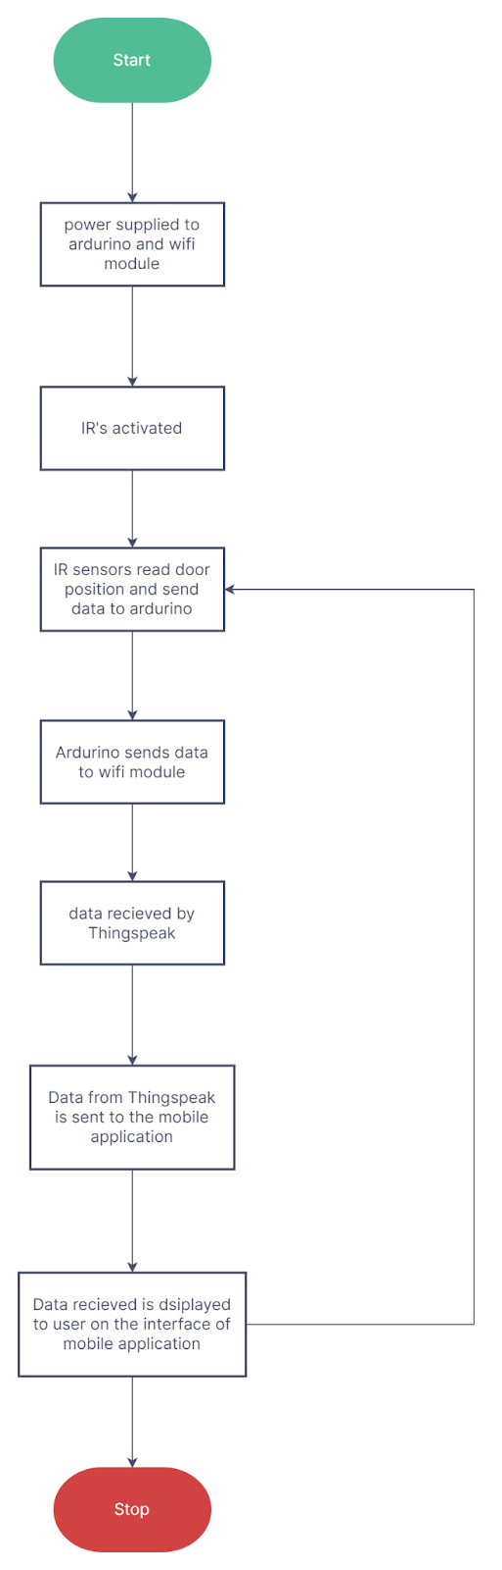

**Admin application flow**

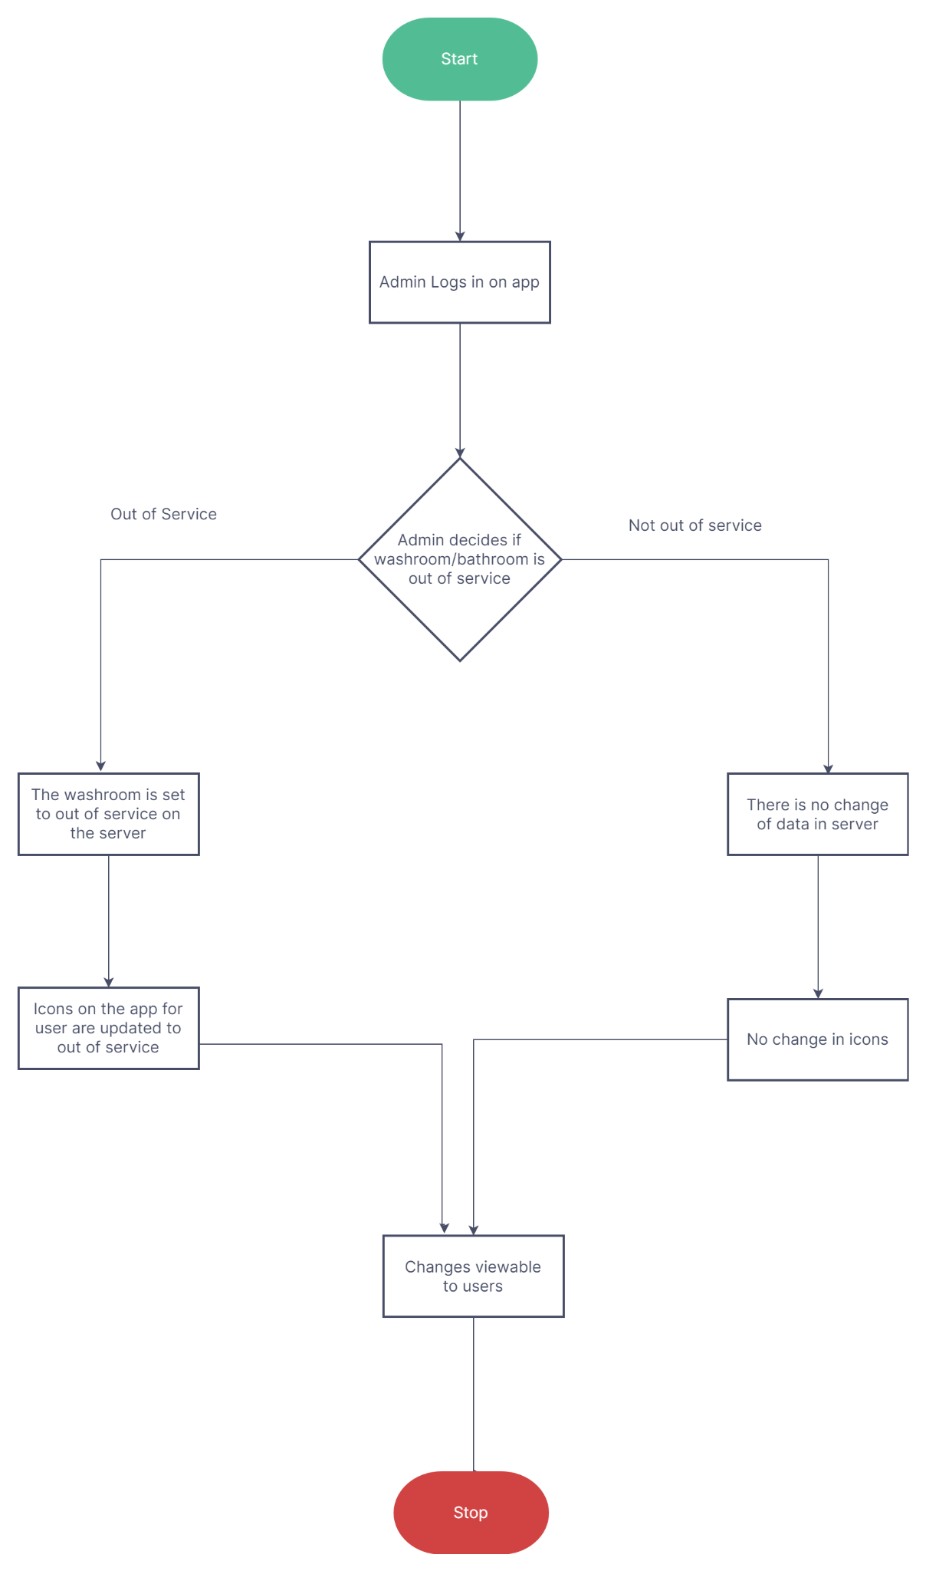

**Code (Input / Execution / Output)**

**ThingSpeak**

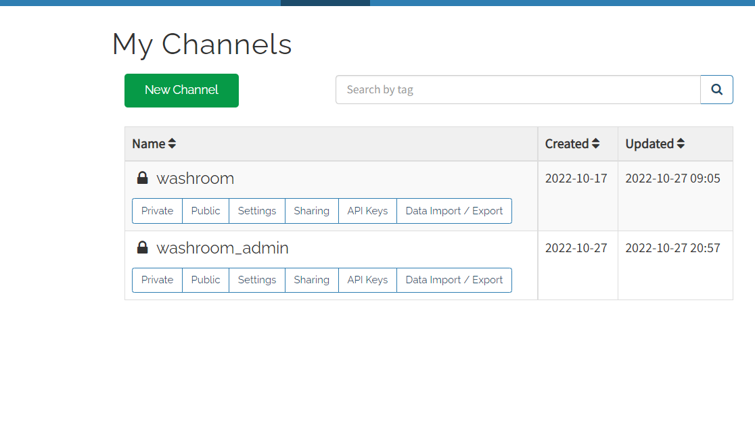

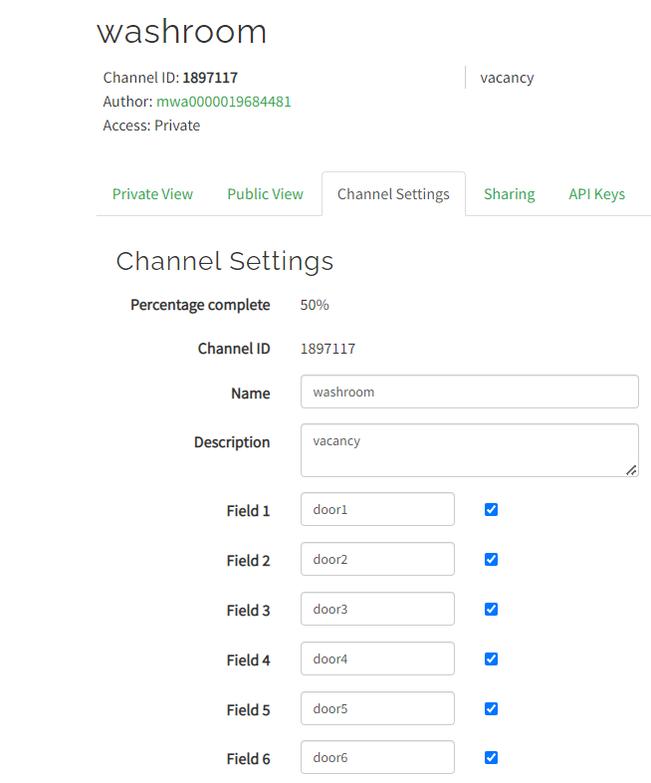

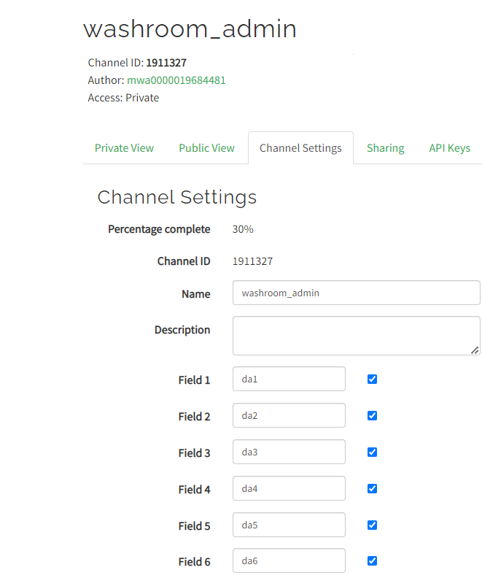

**Arduino**

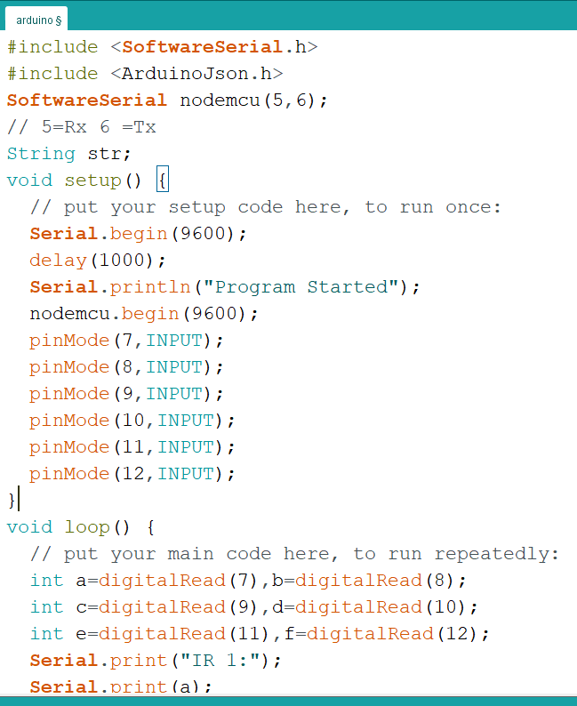

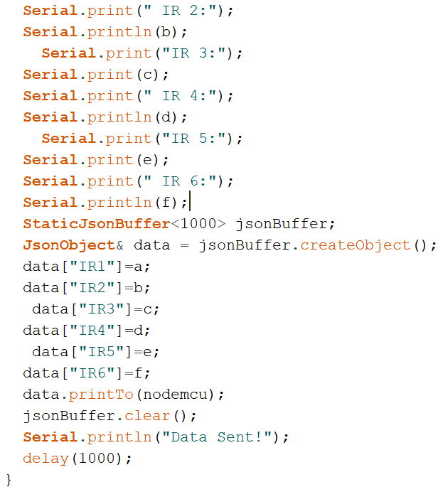

**NodeMcu**

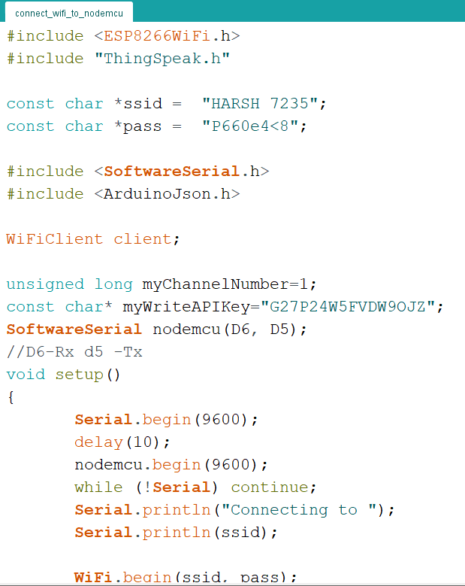

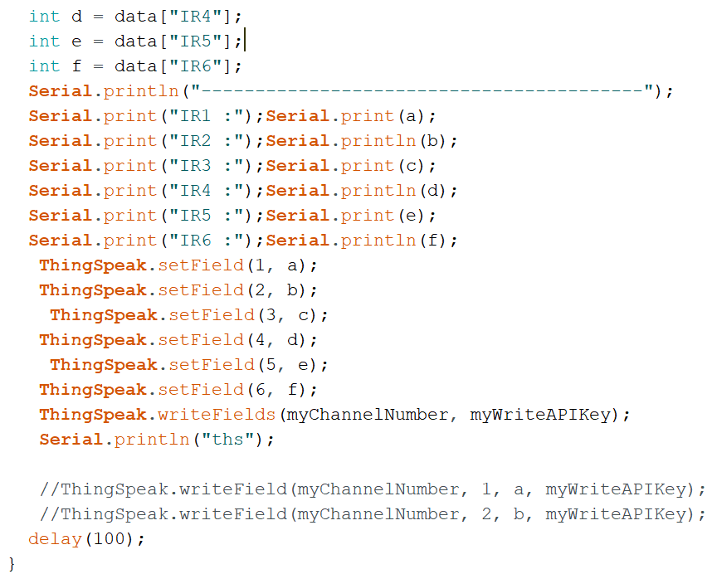

**App Development**

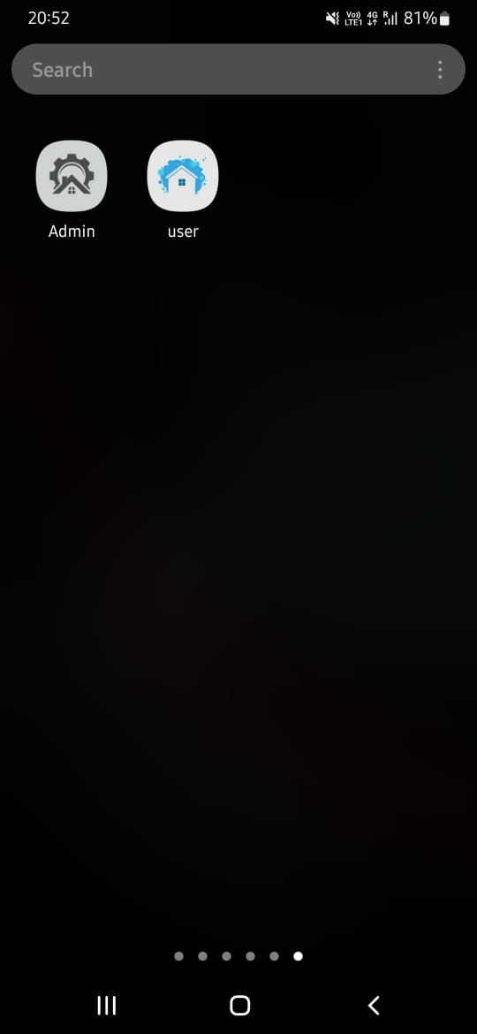

**Android Studio (User-App)**

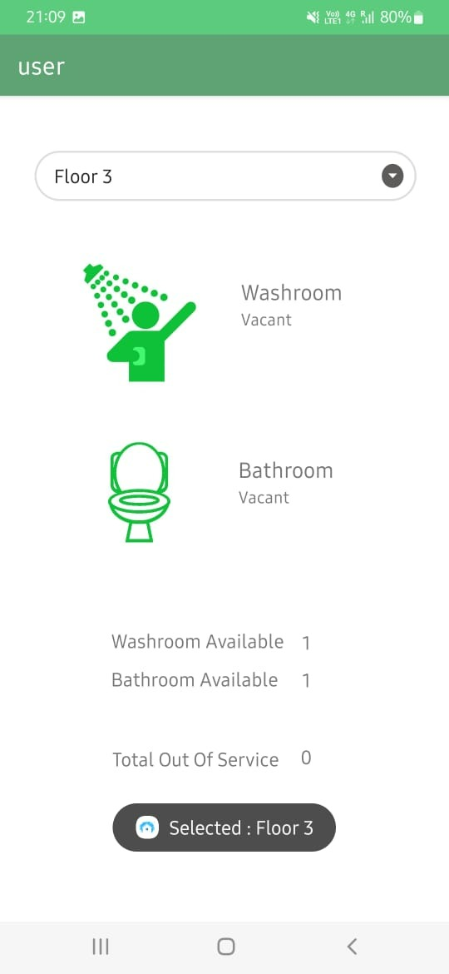

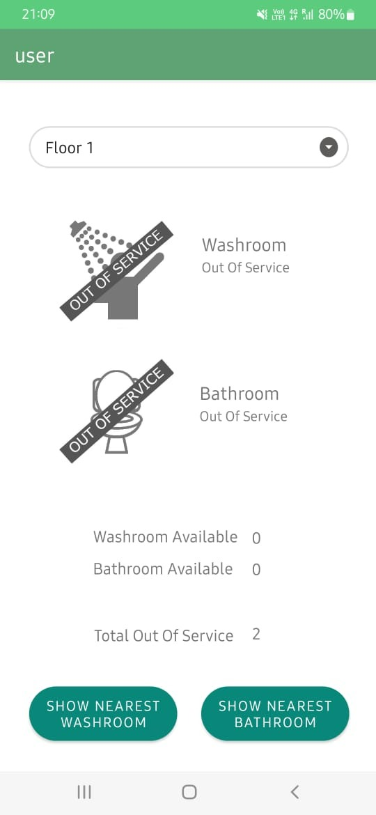

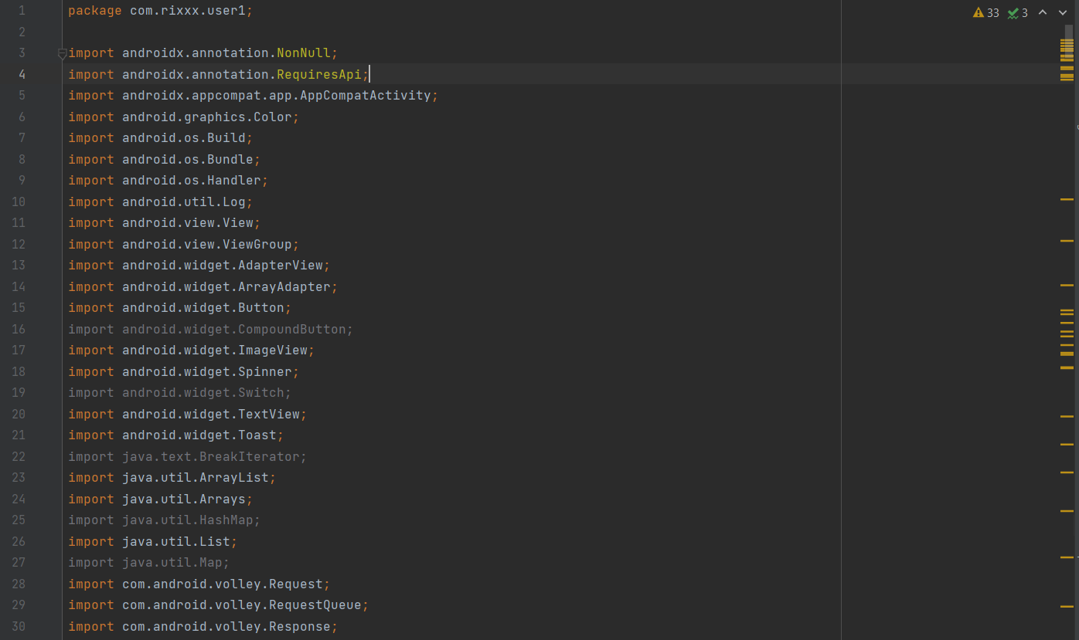

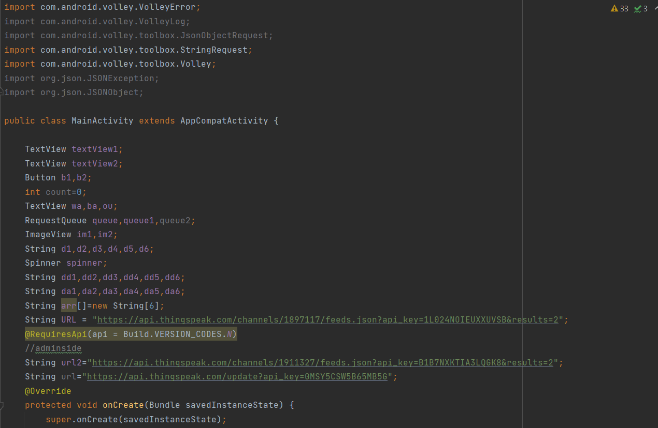

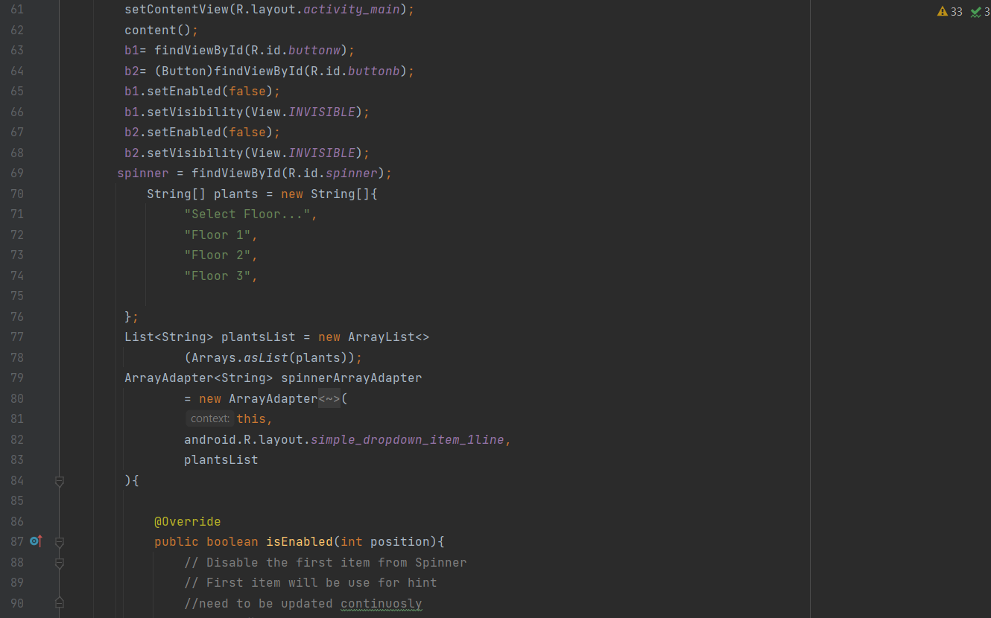

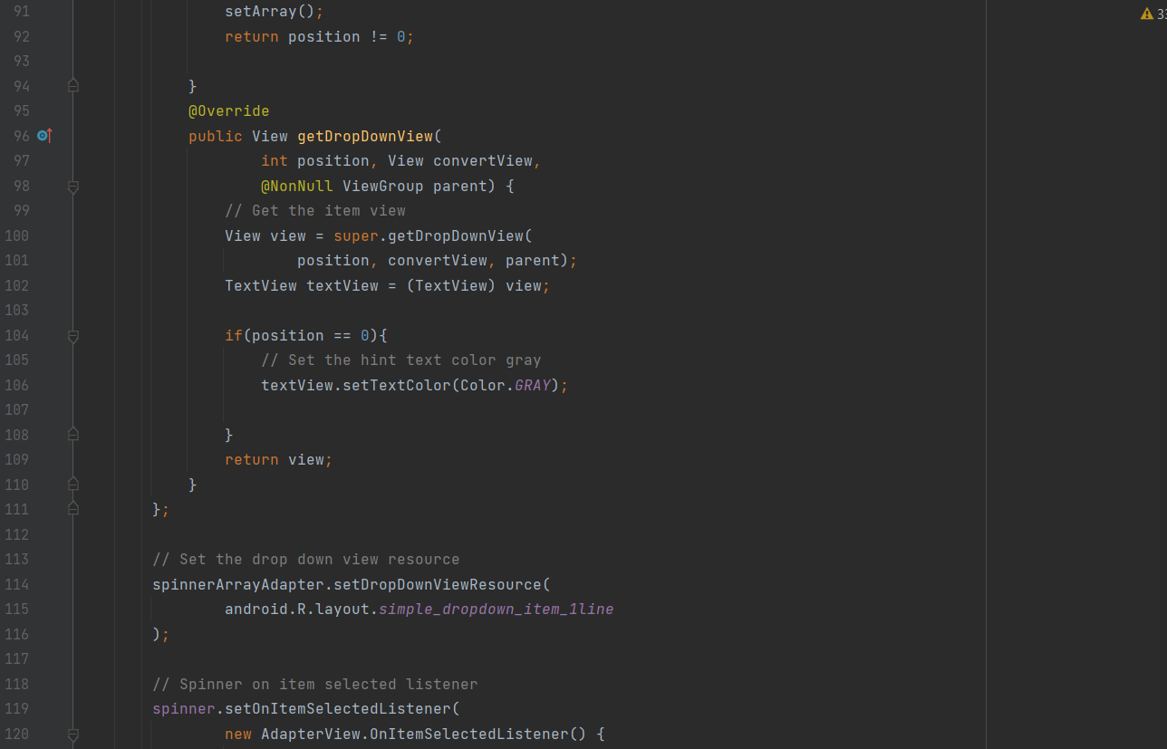

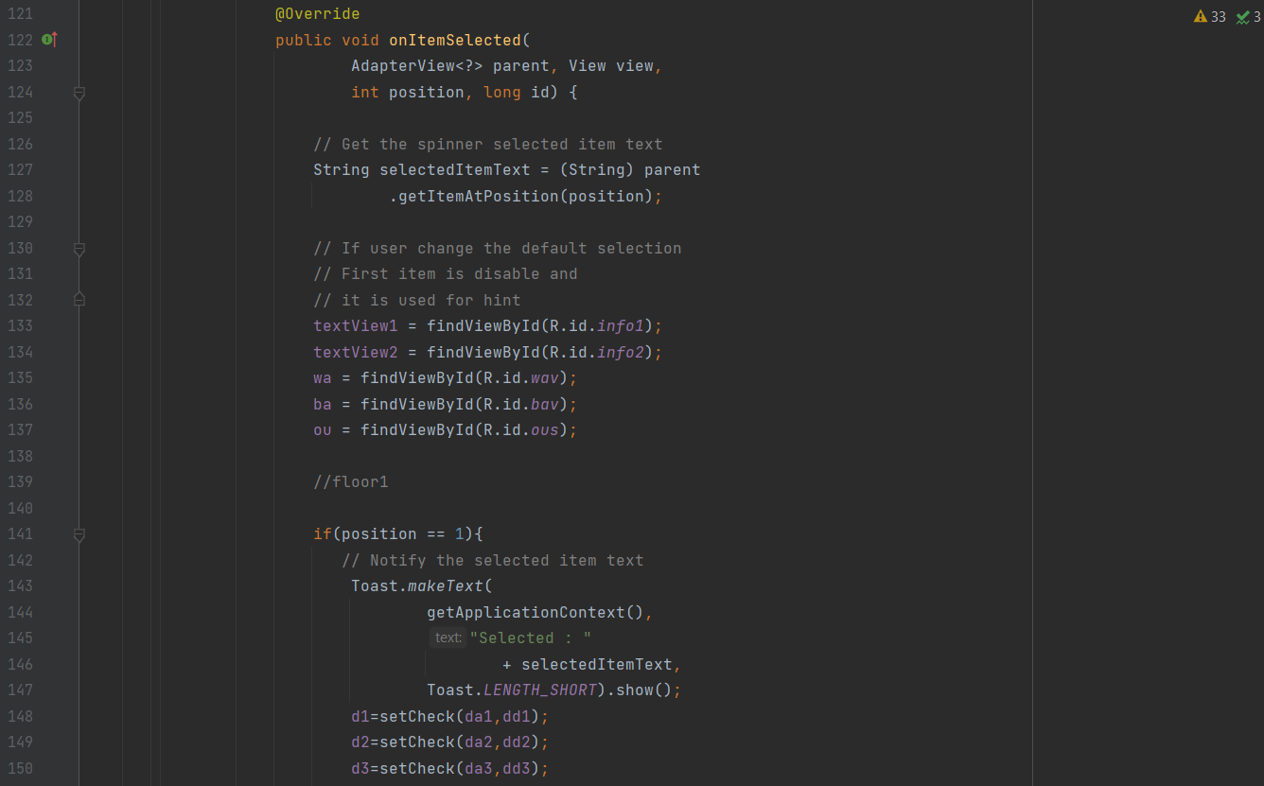

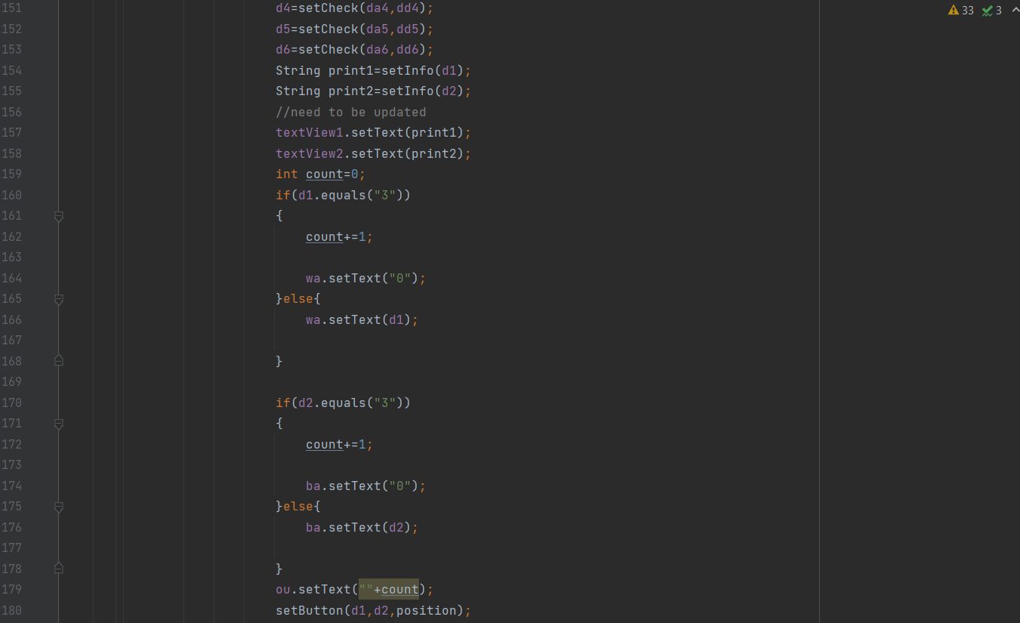

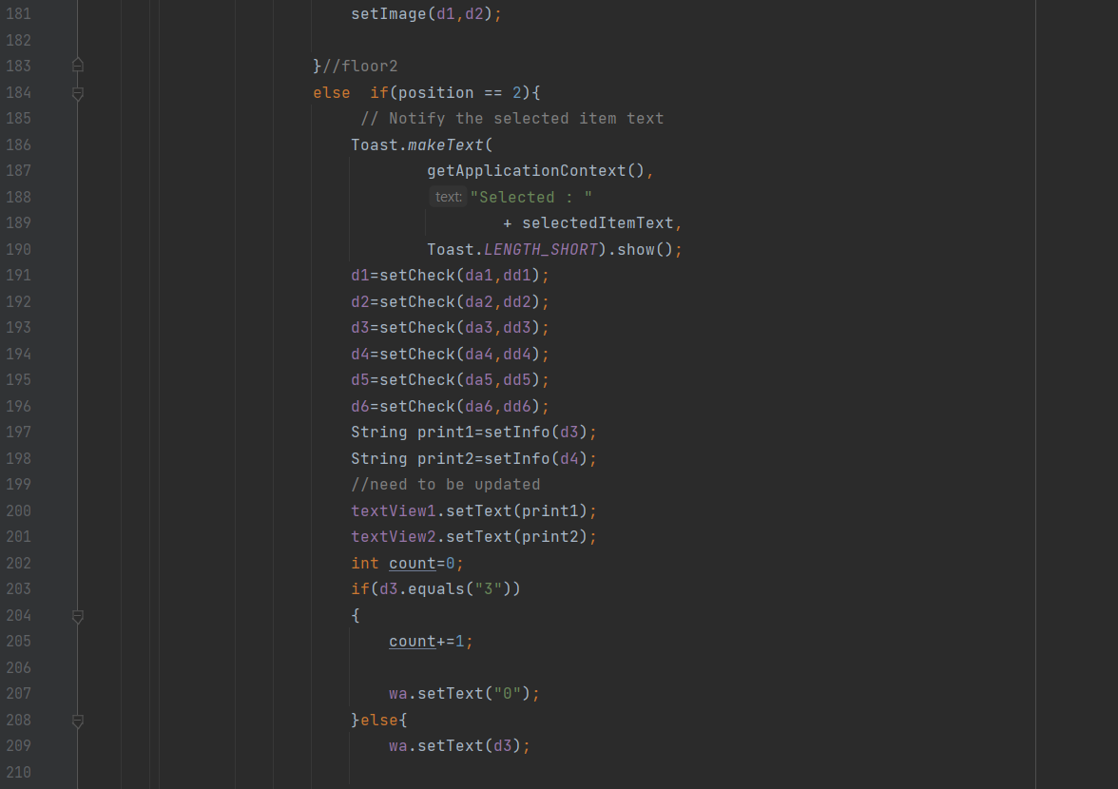

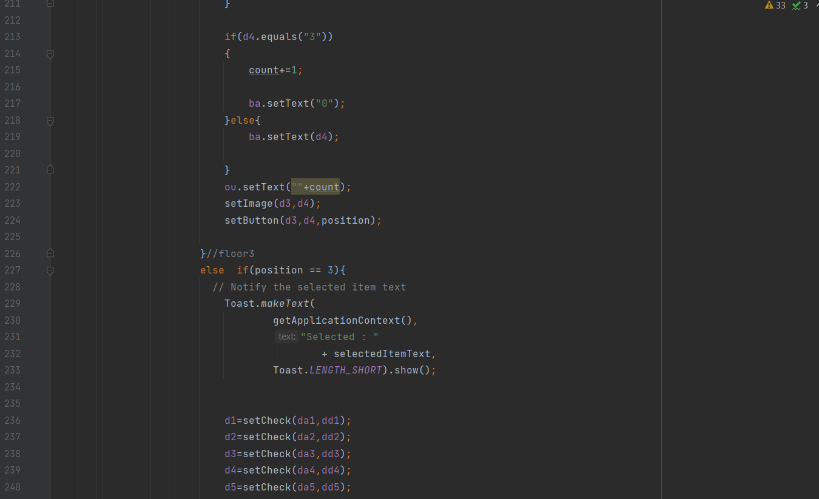

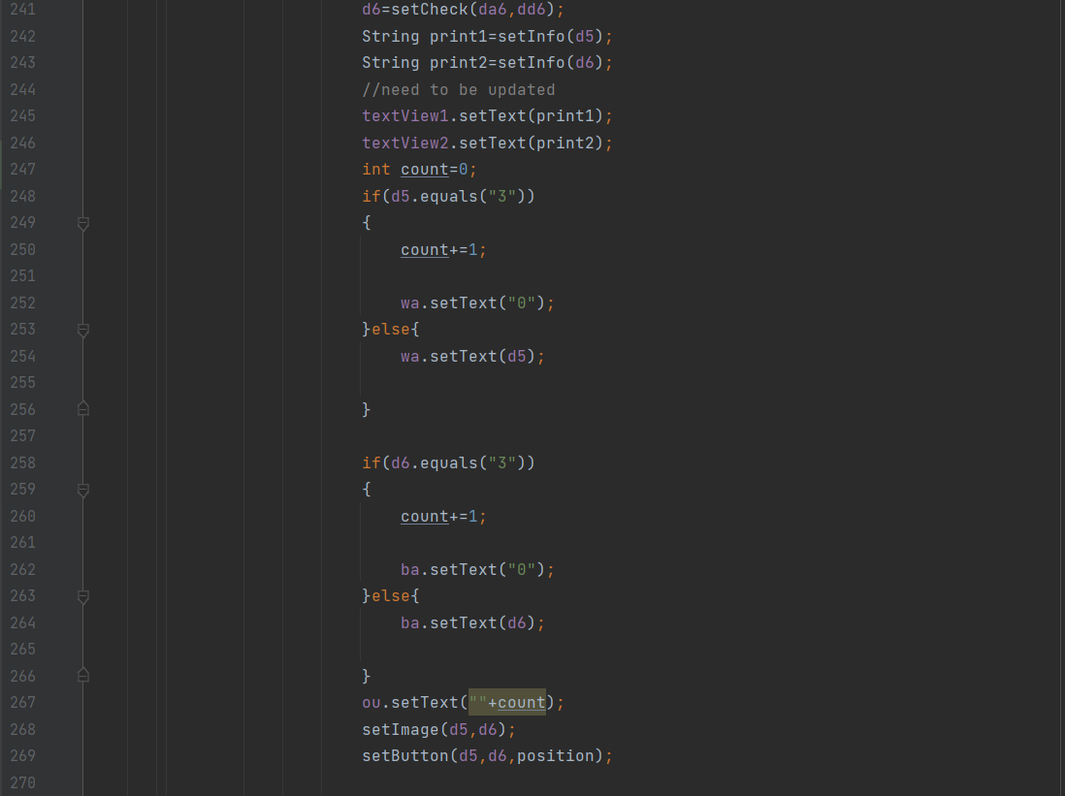

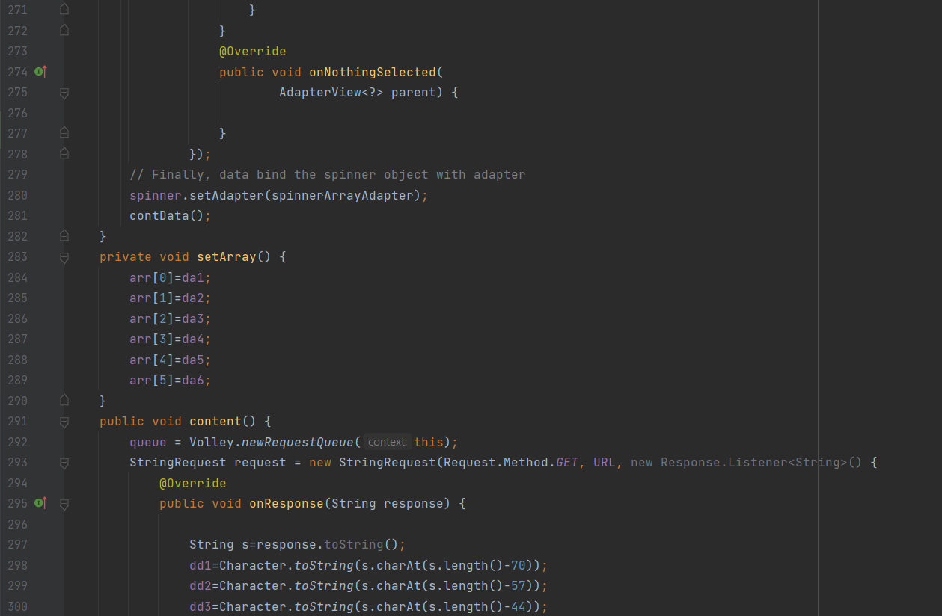

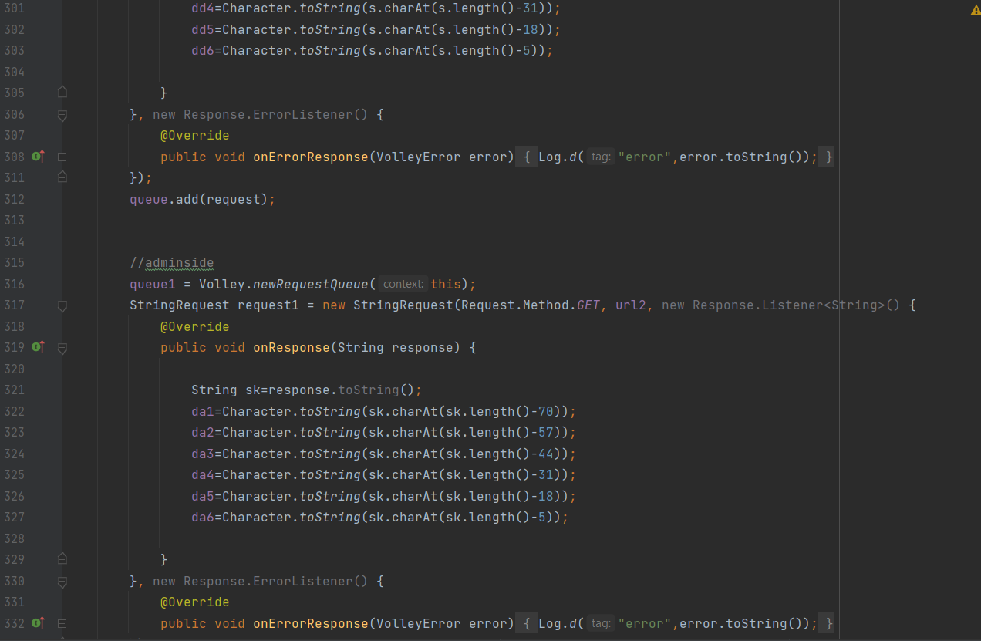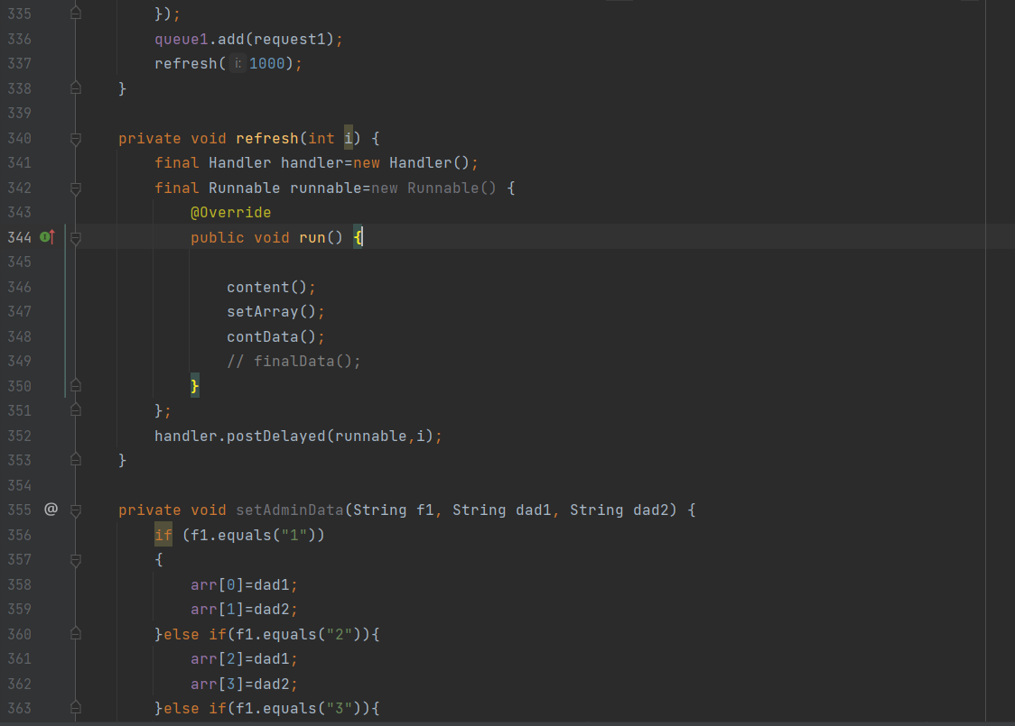

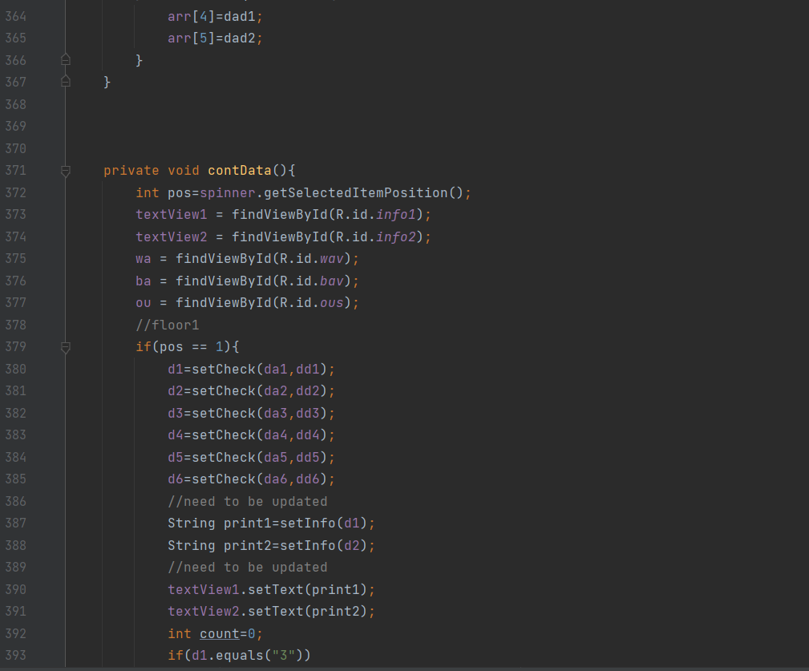

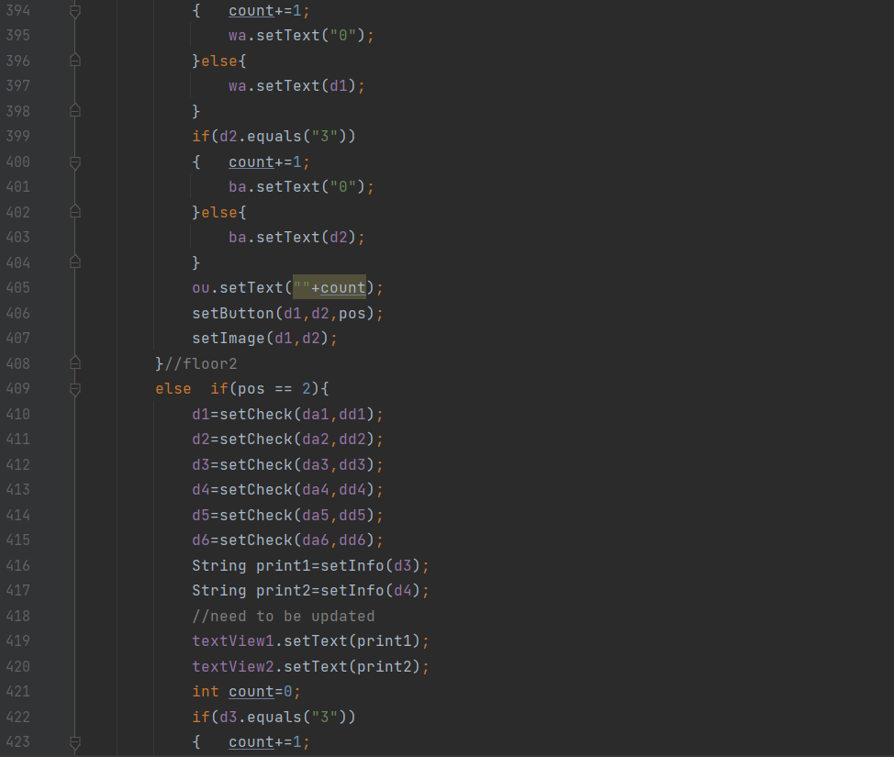

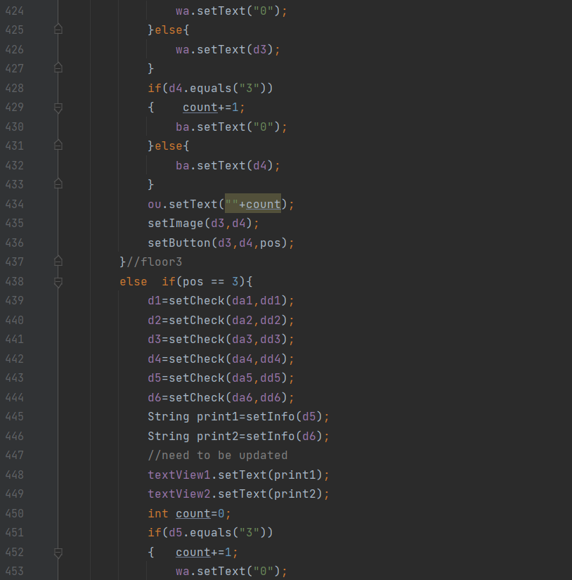

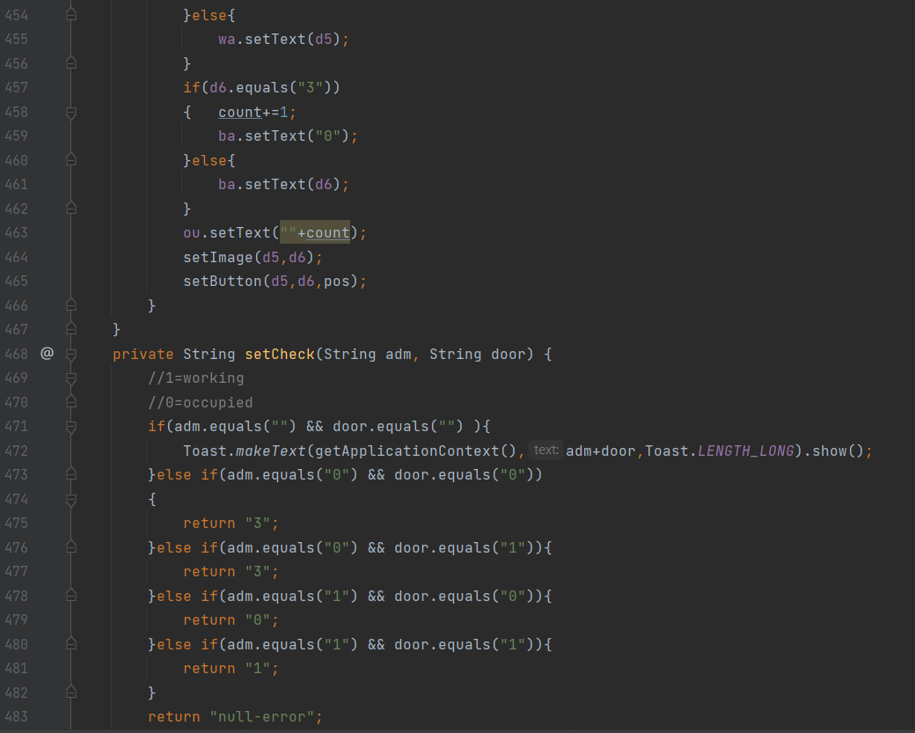

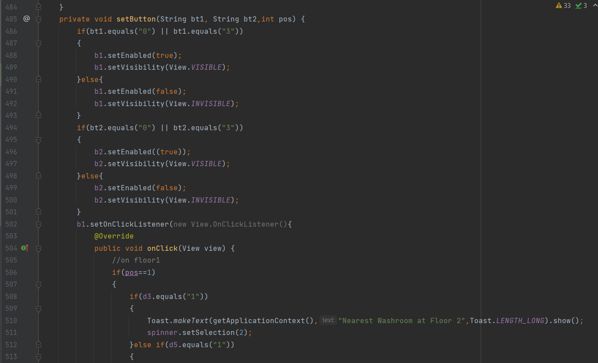

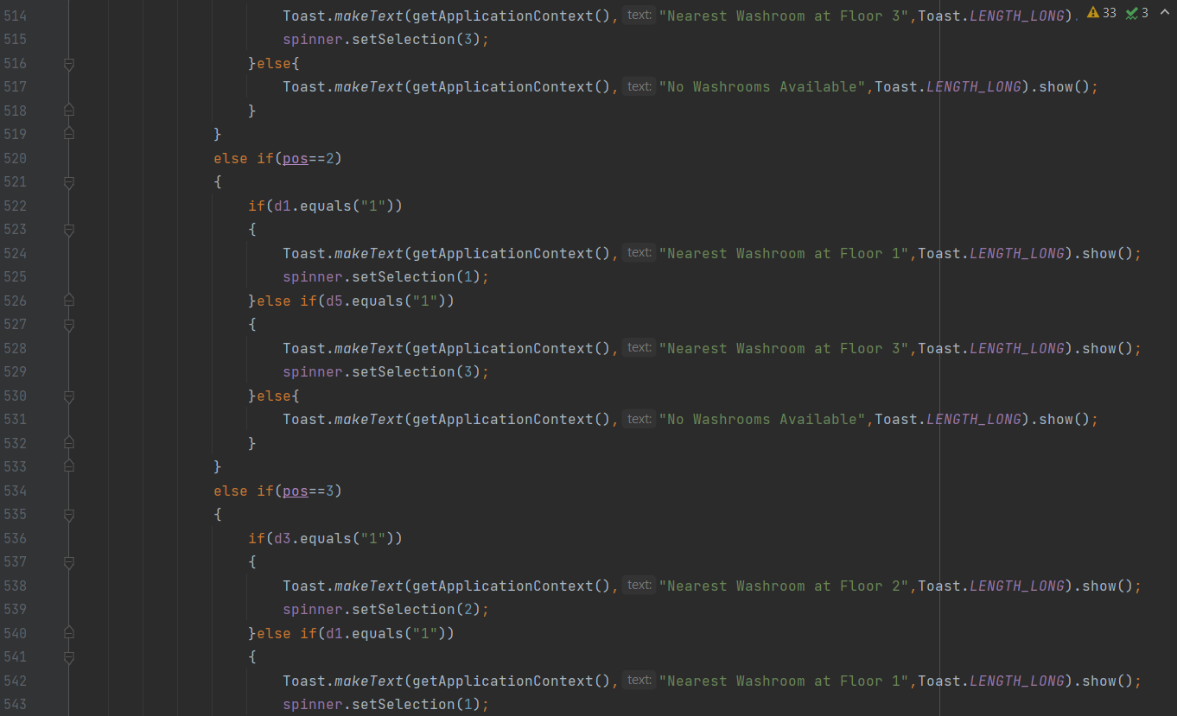

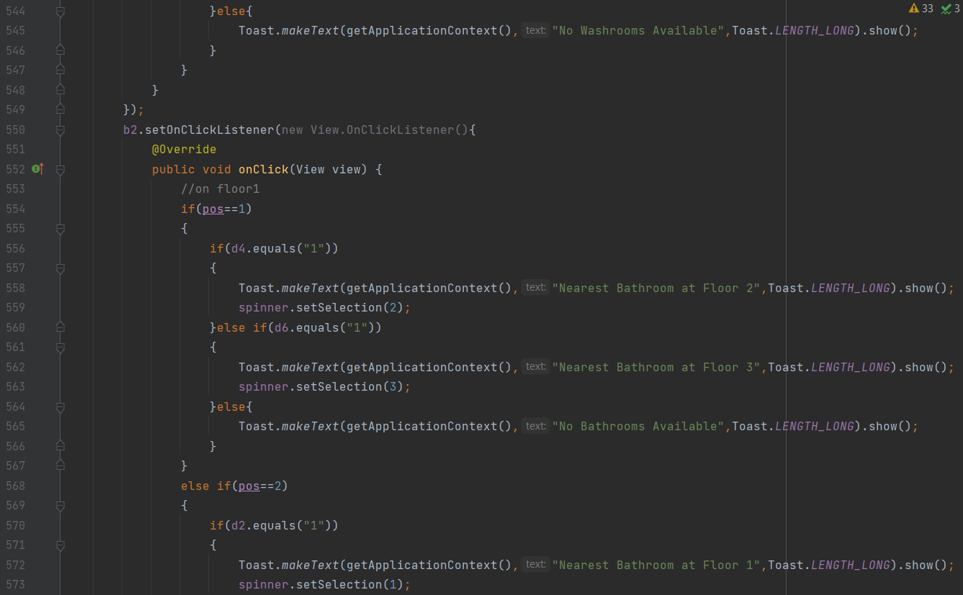

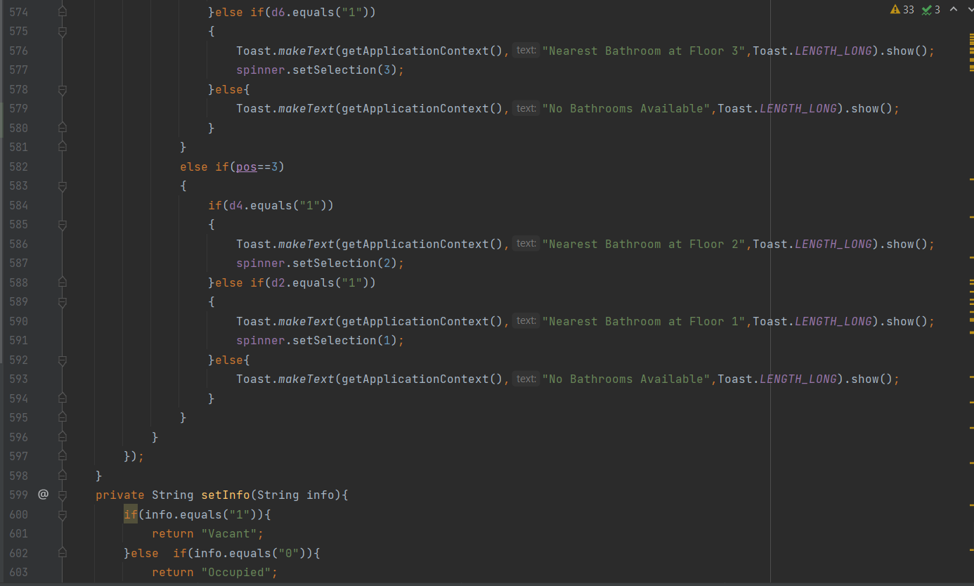

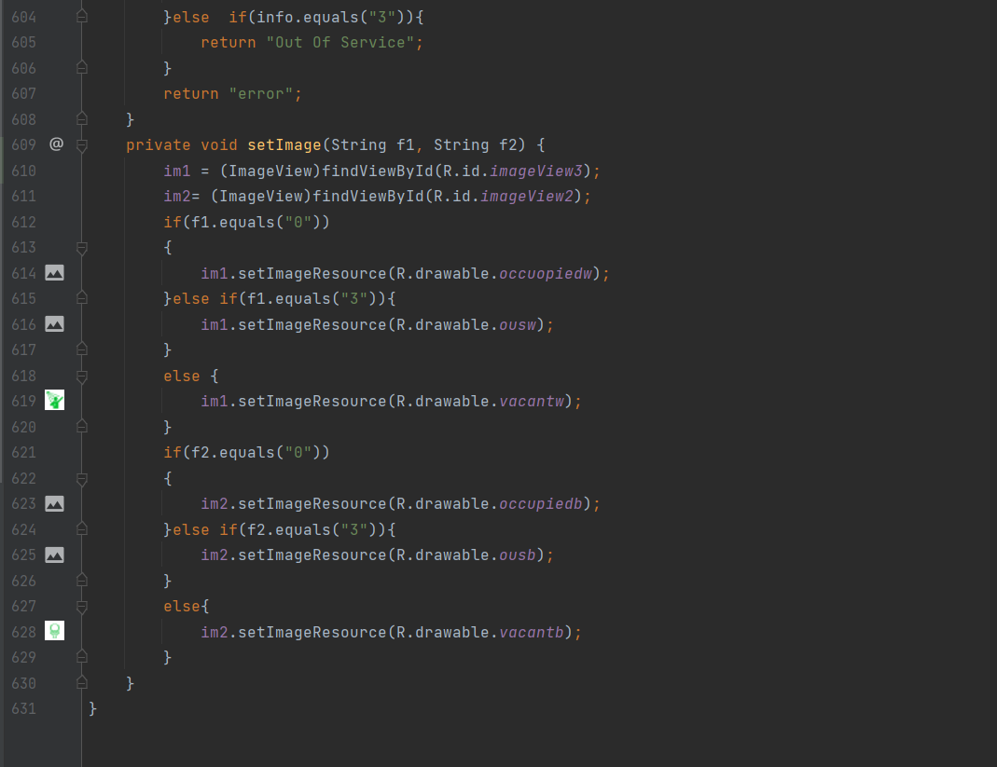

**AndroidStudio (Admin App)**

**MainActivity.java**

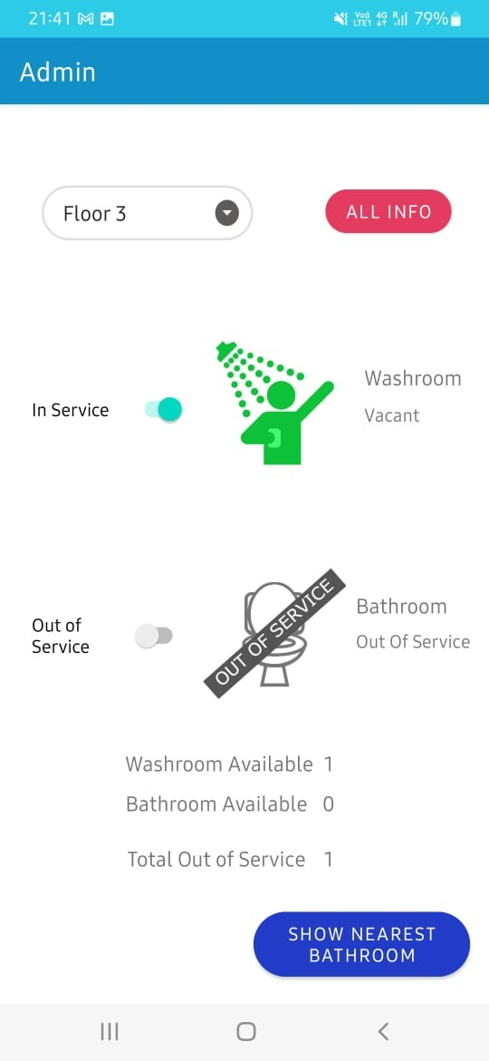

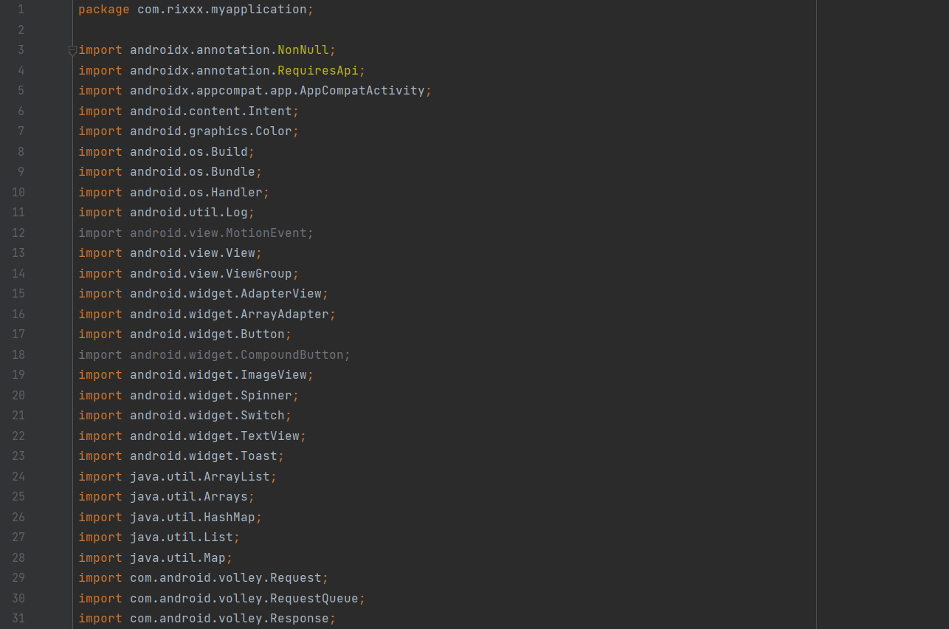

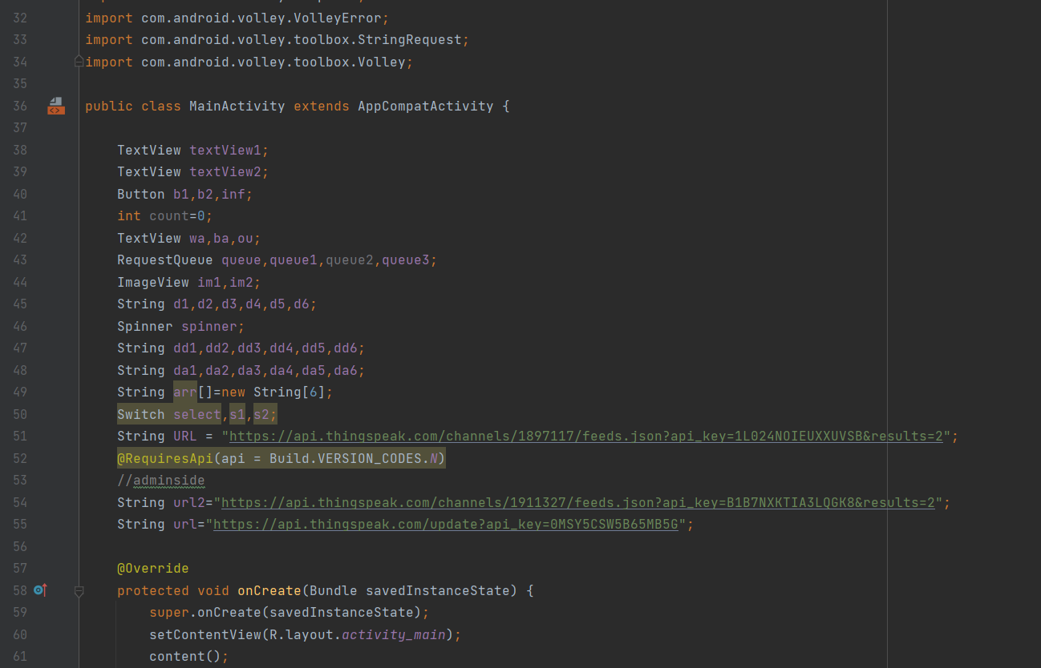

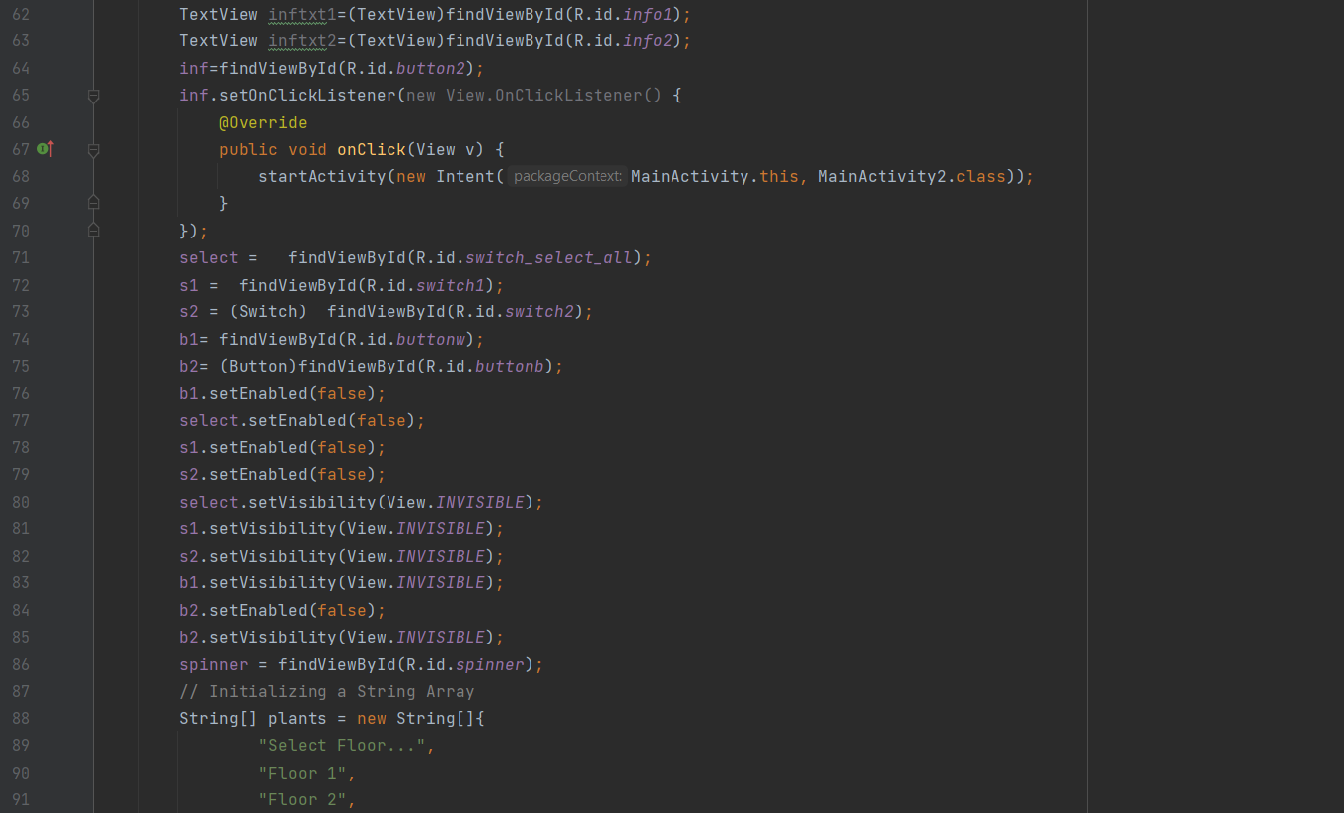

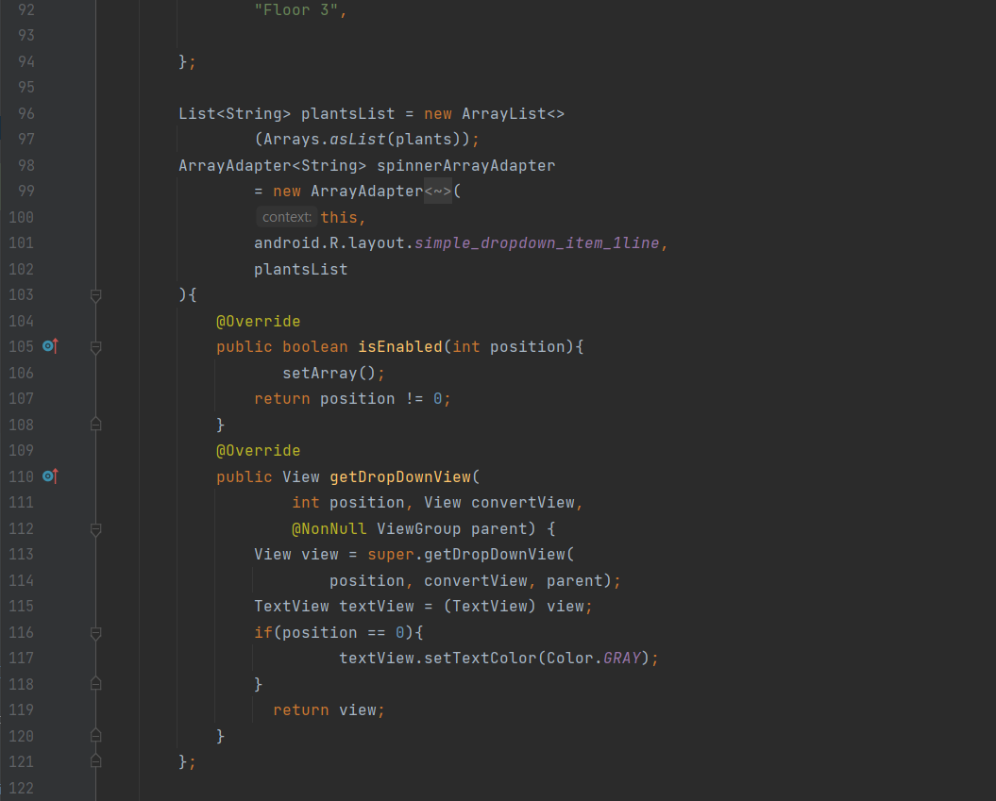

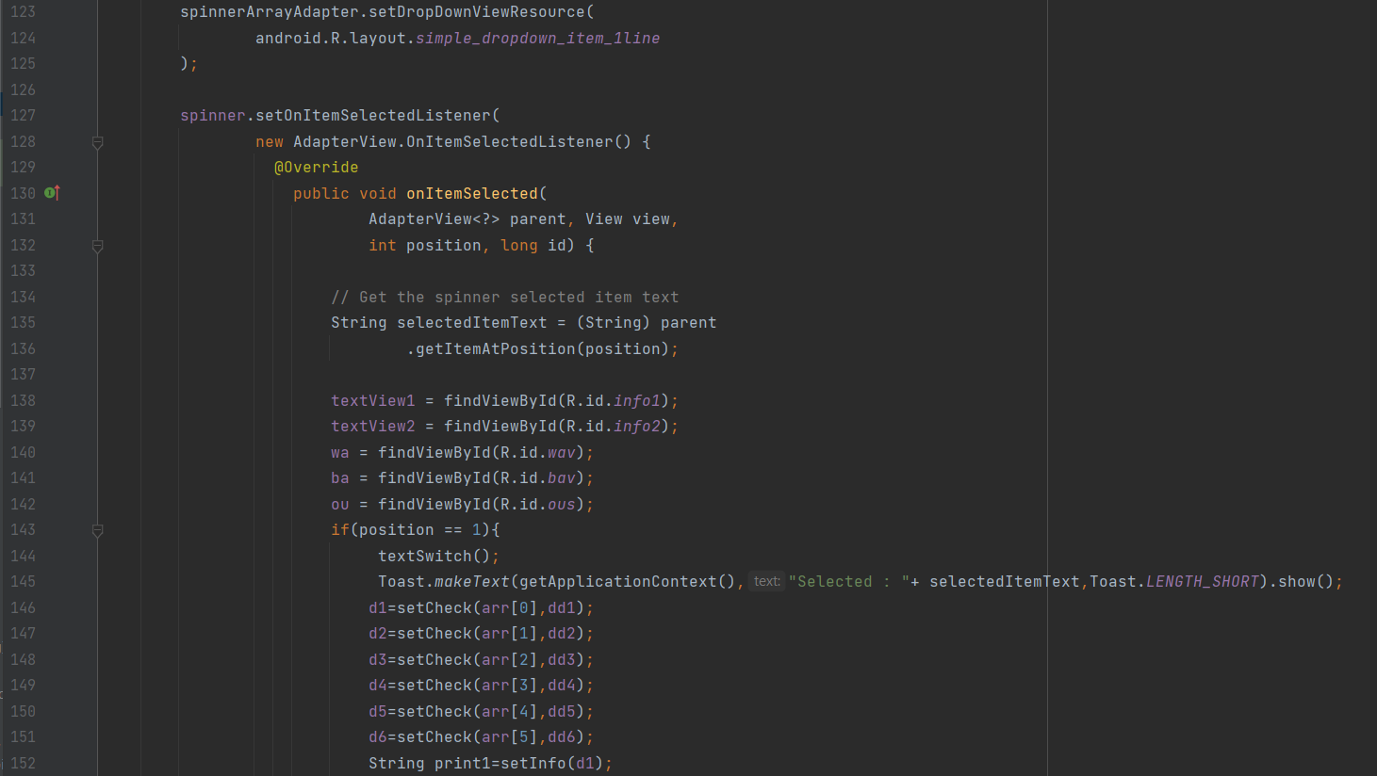

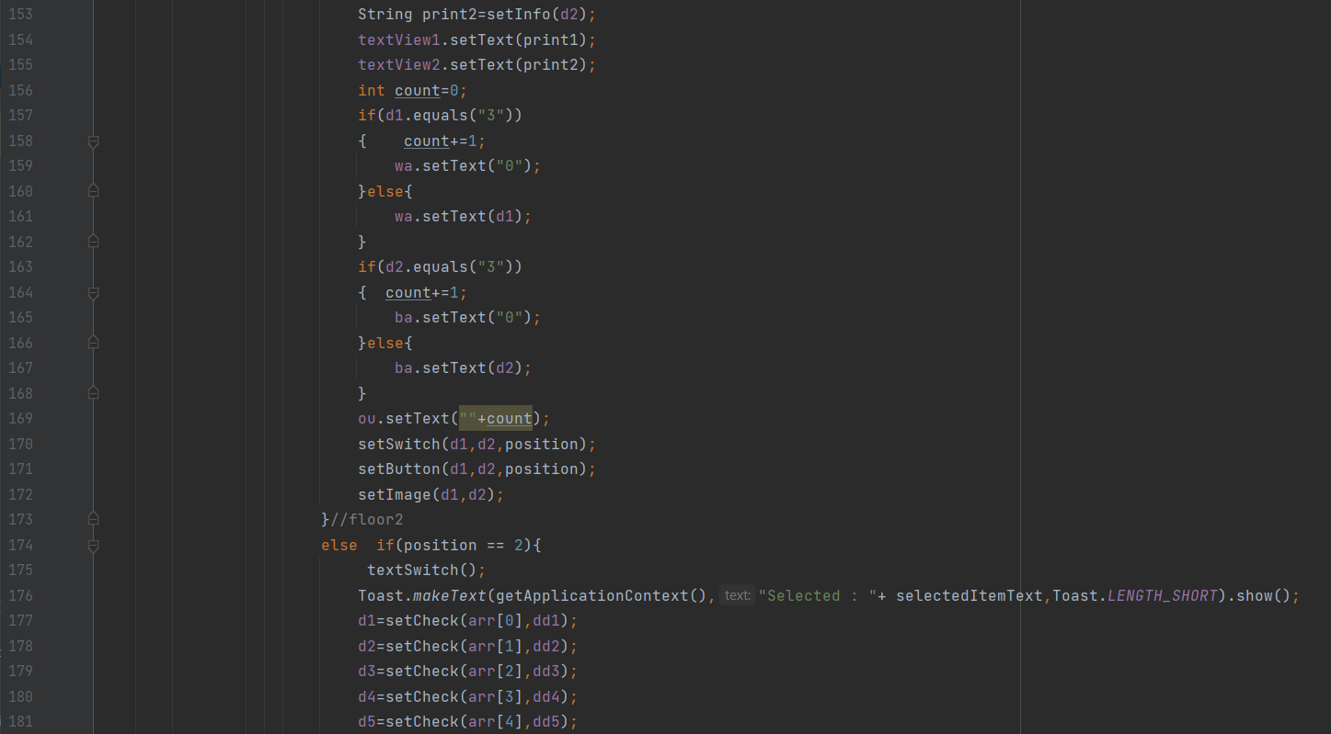

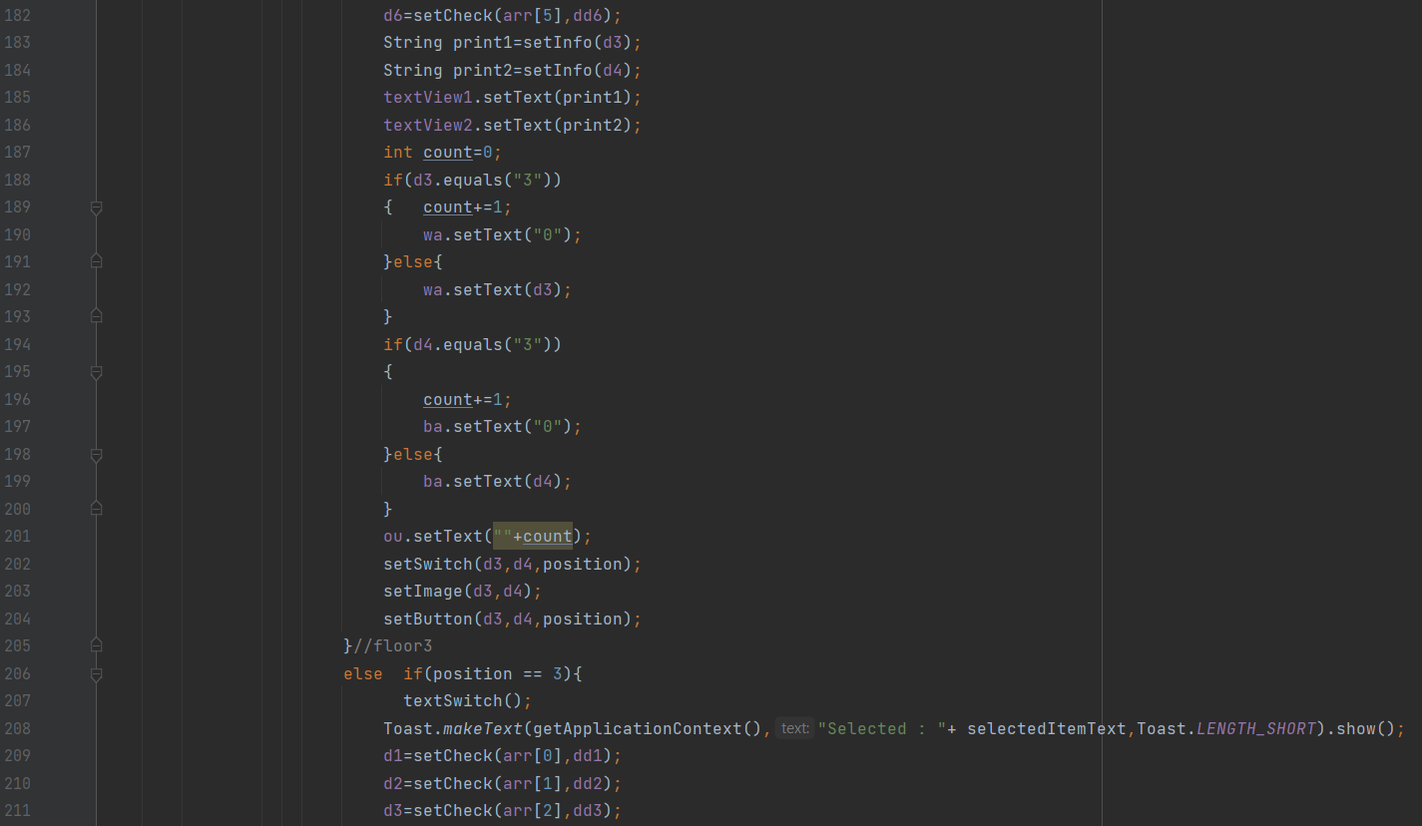

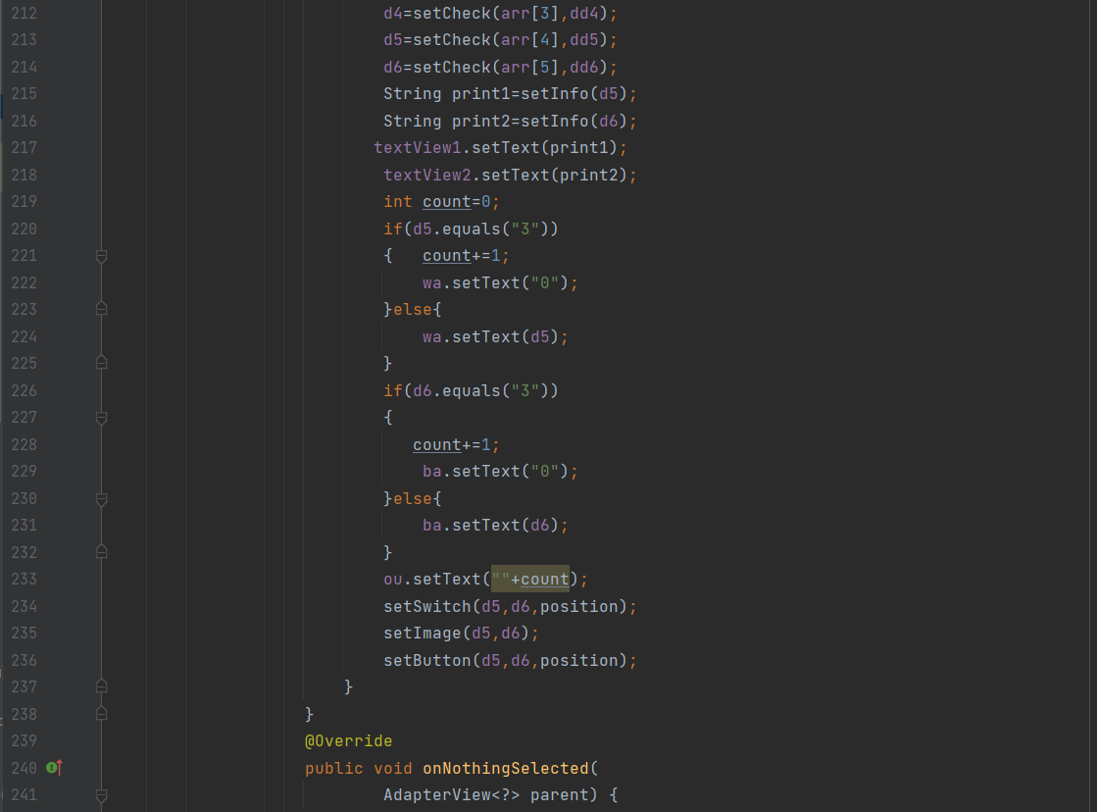

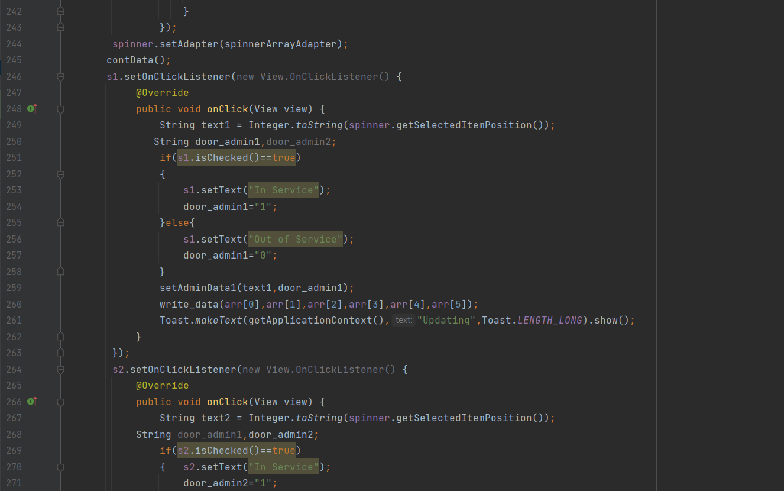

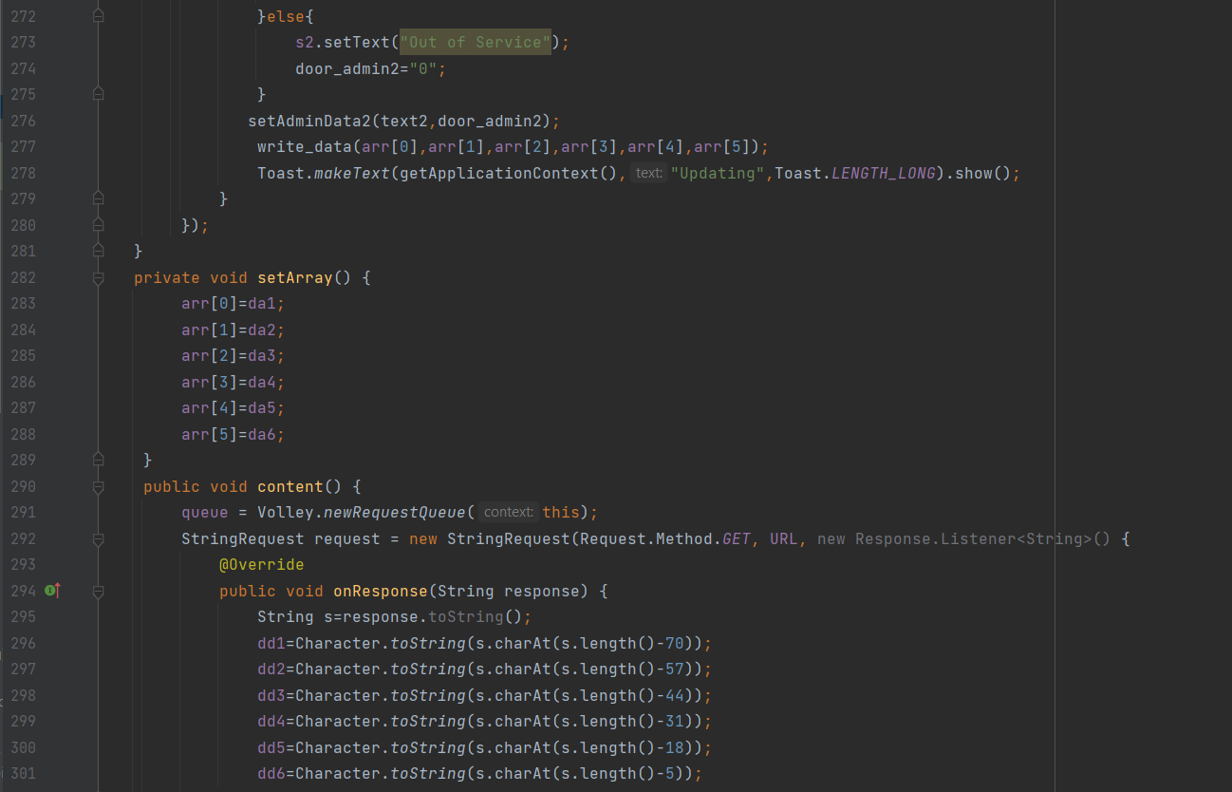

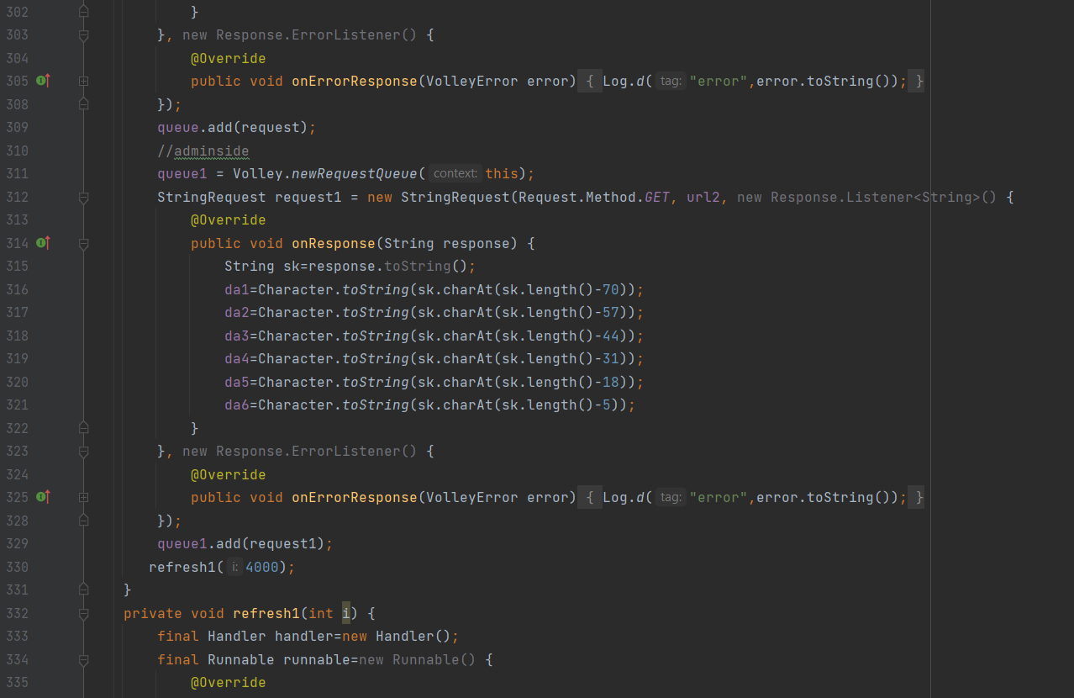

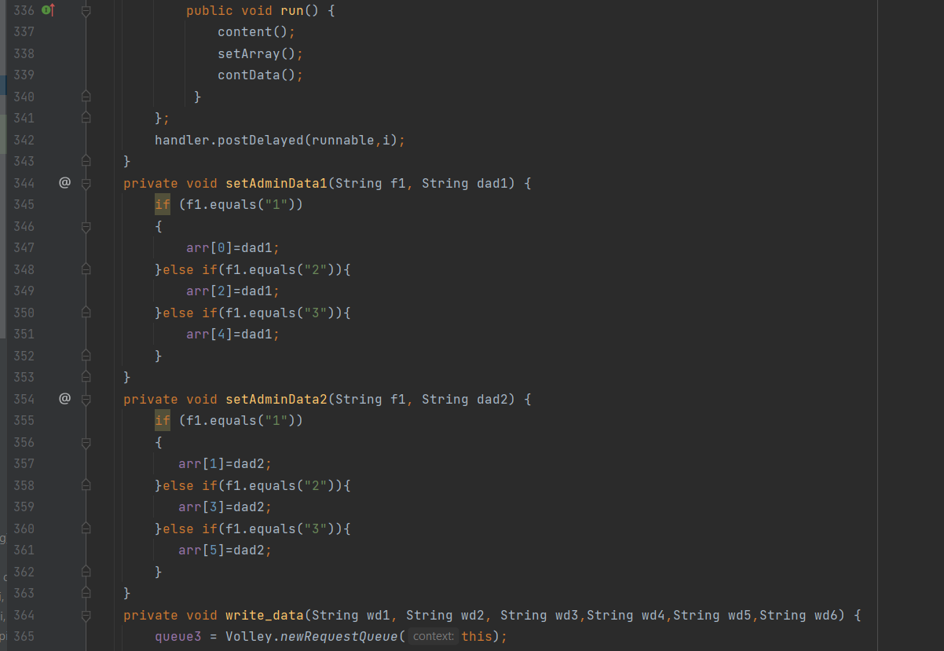

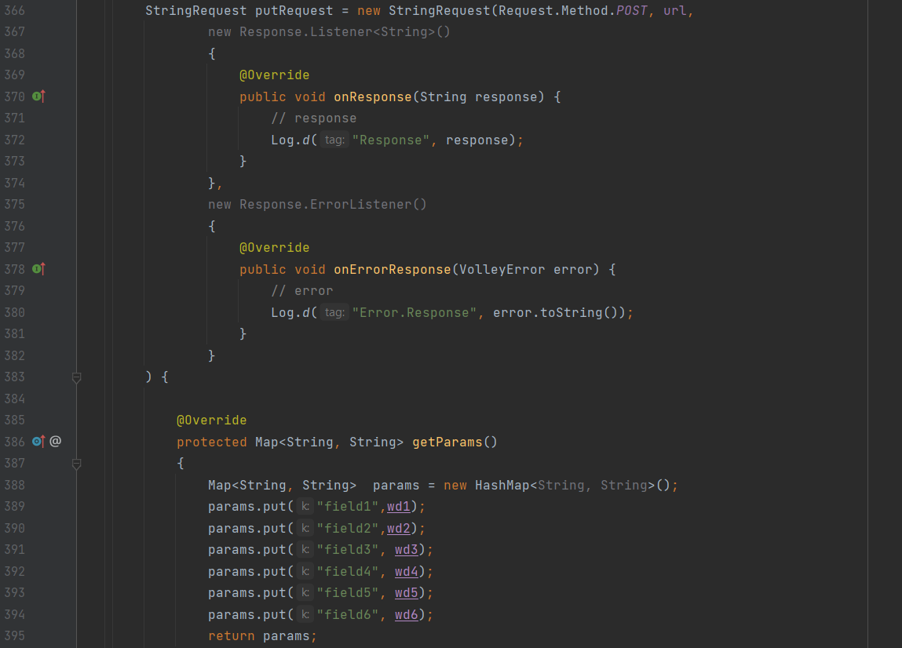

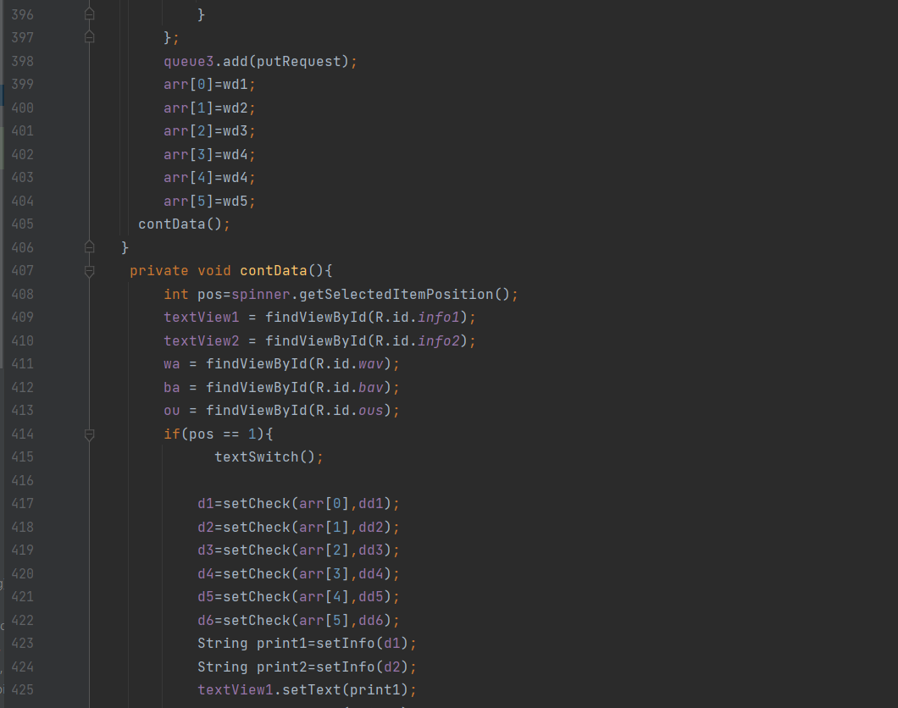

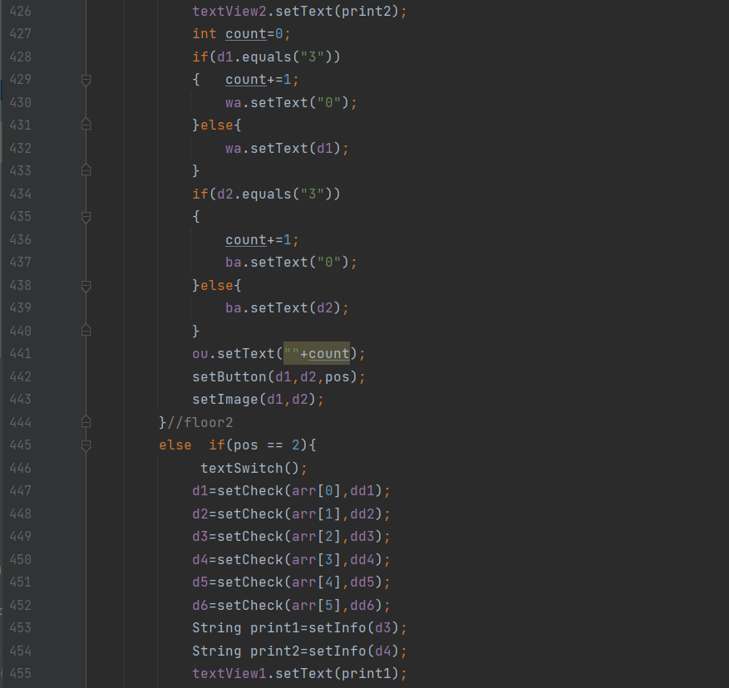

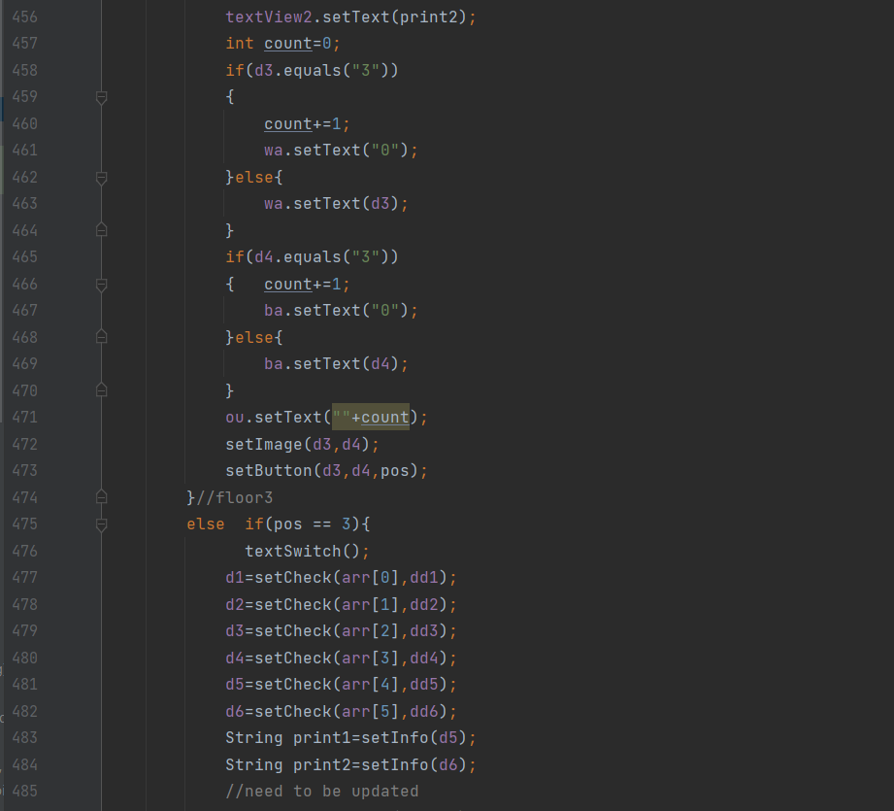

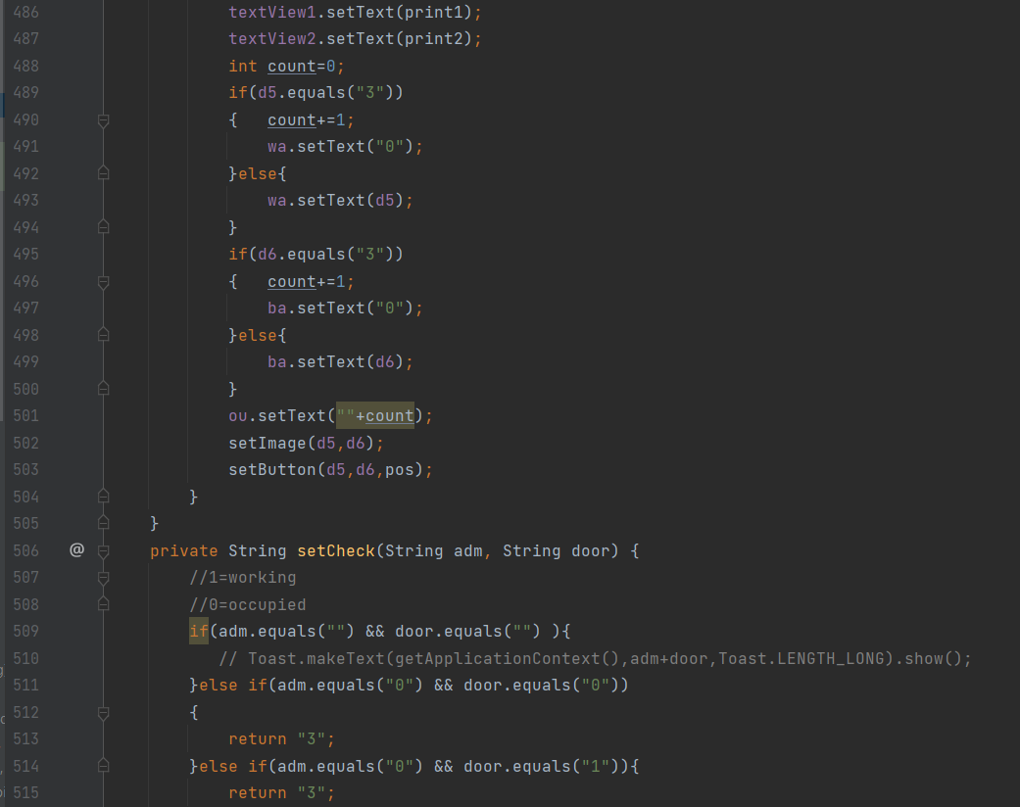

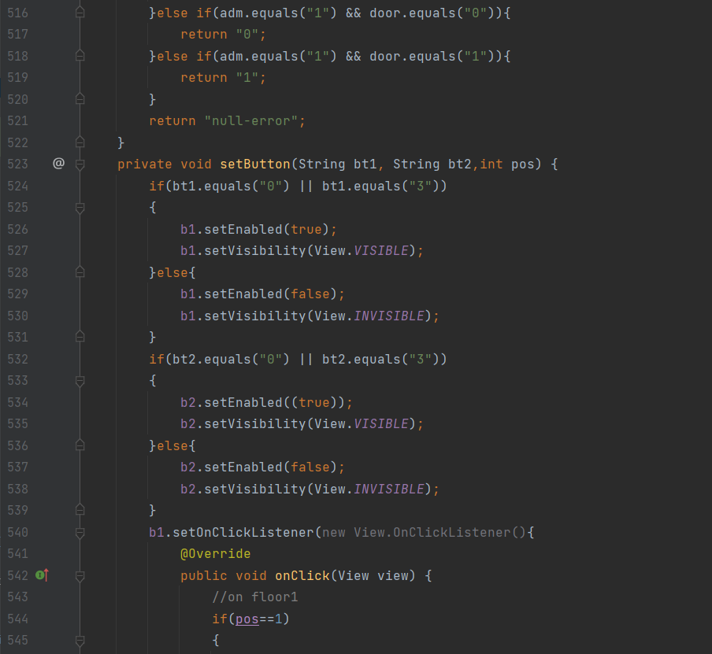

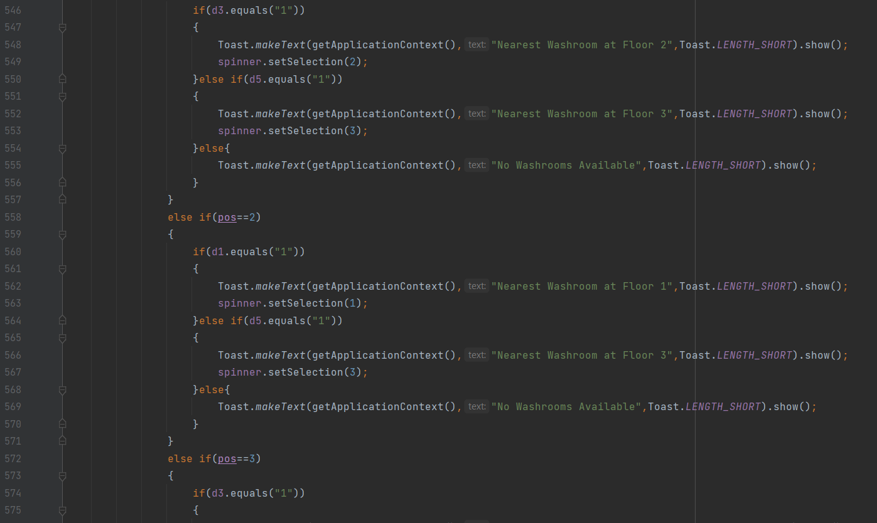

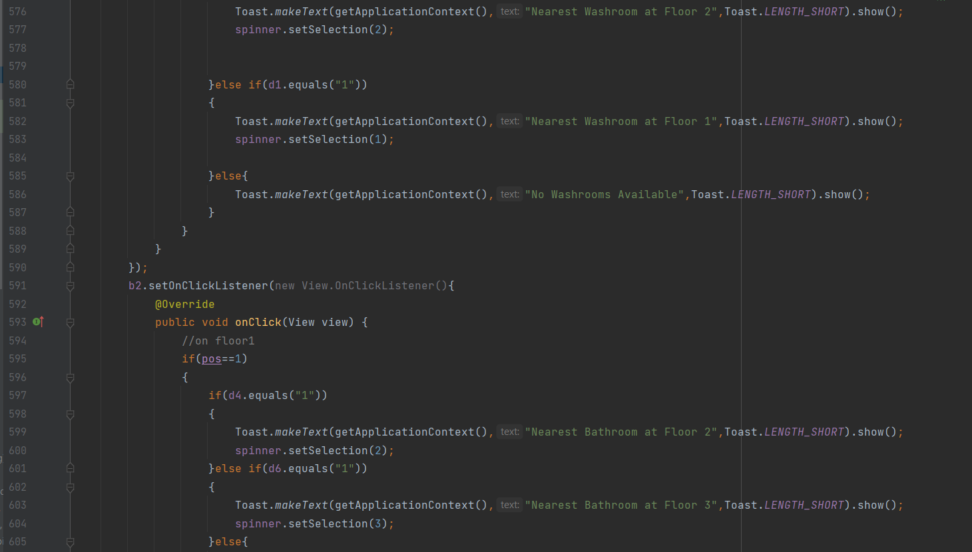

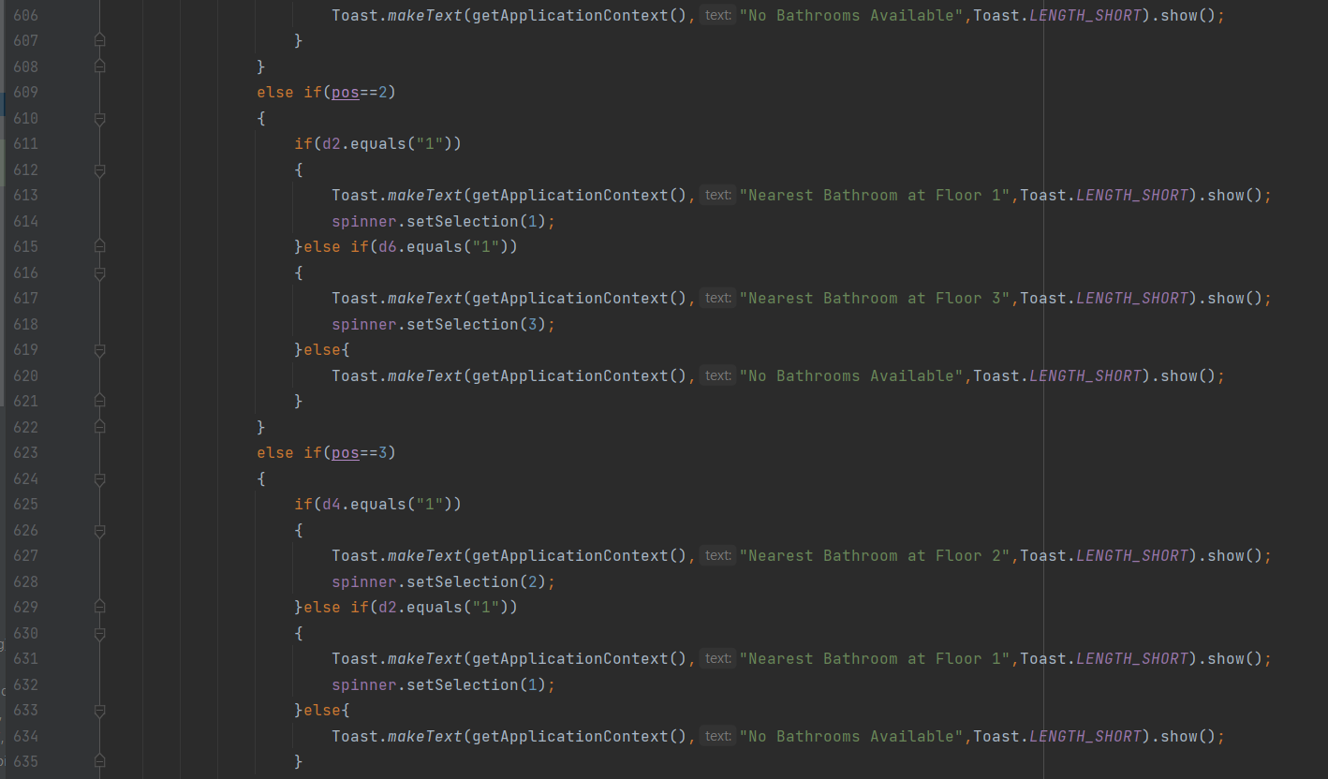

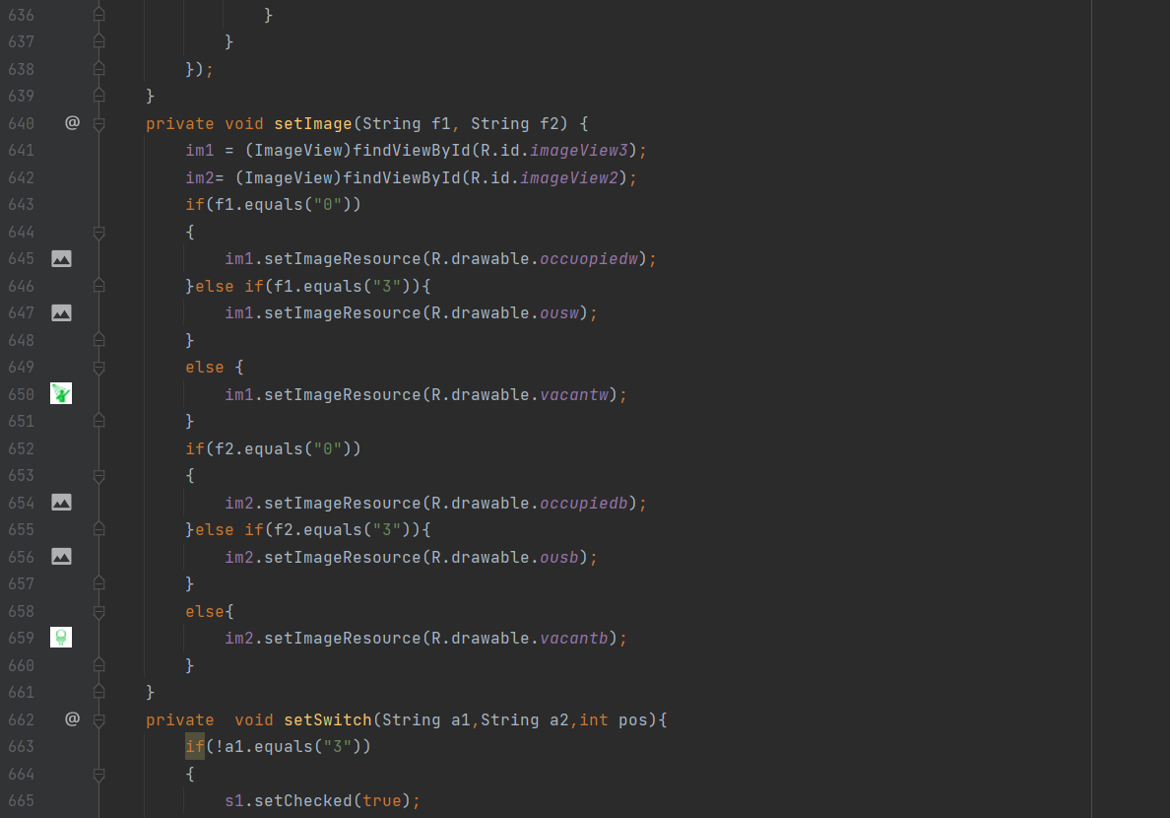

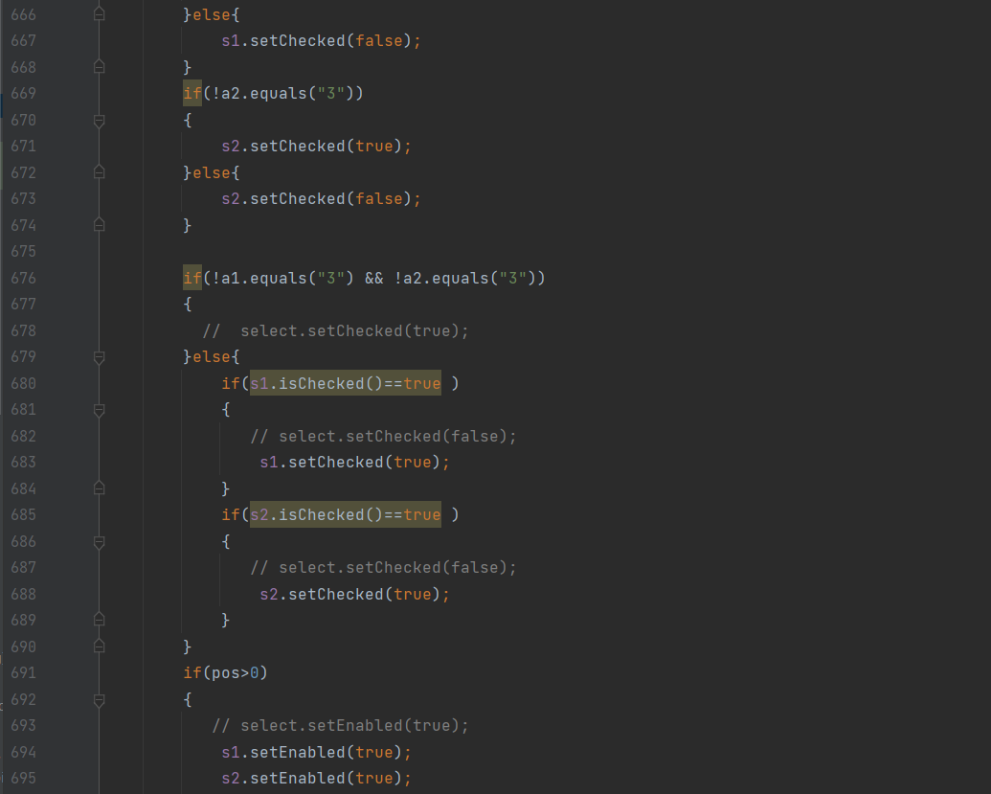

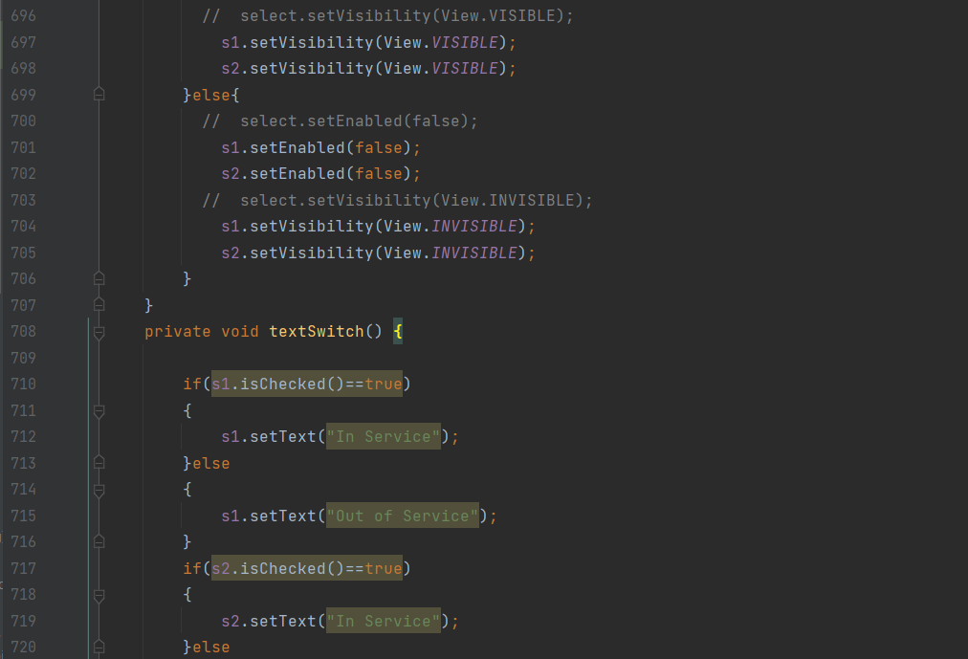

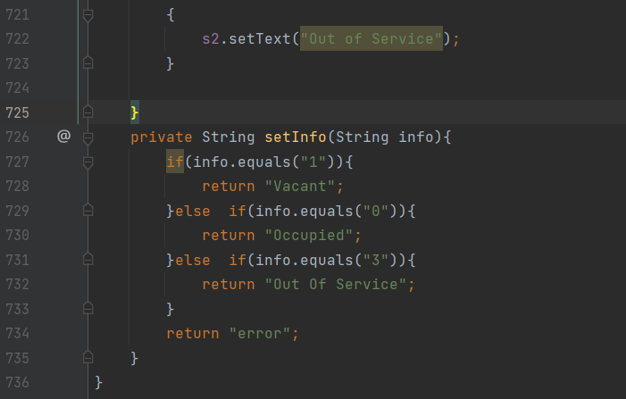

**MainActivity2.java(All-info)**

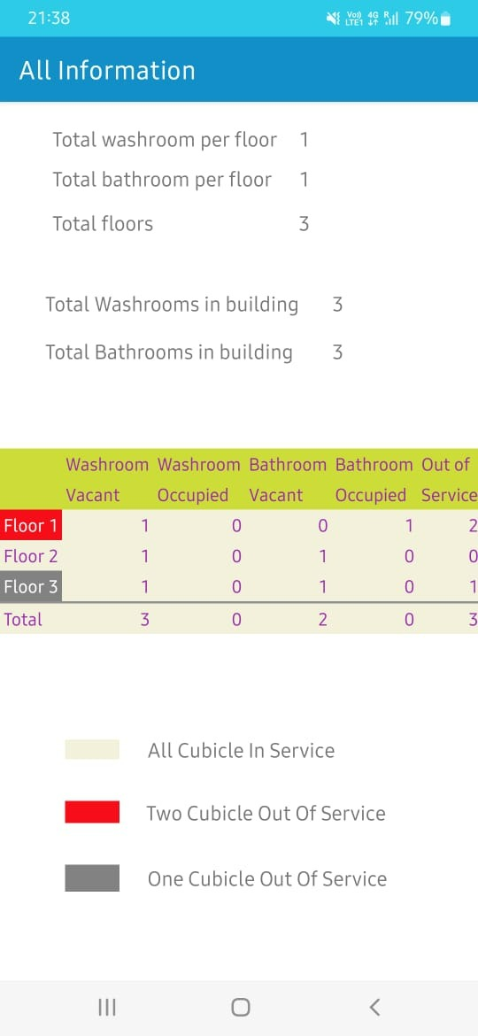

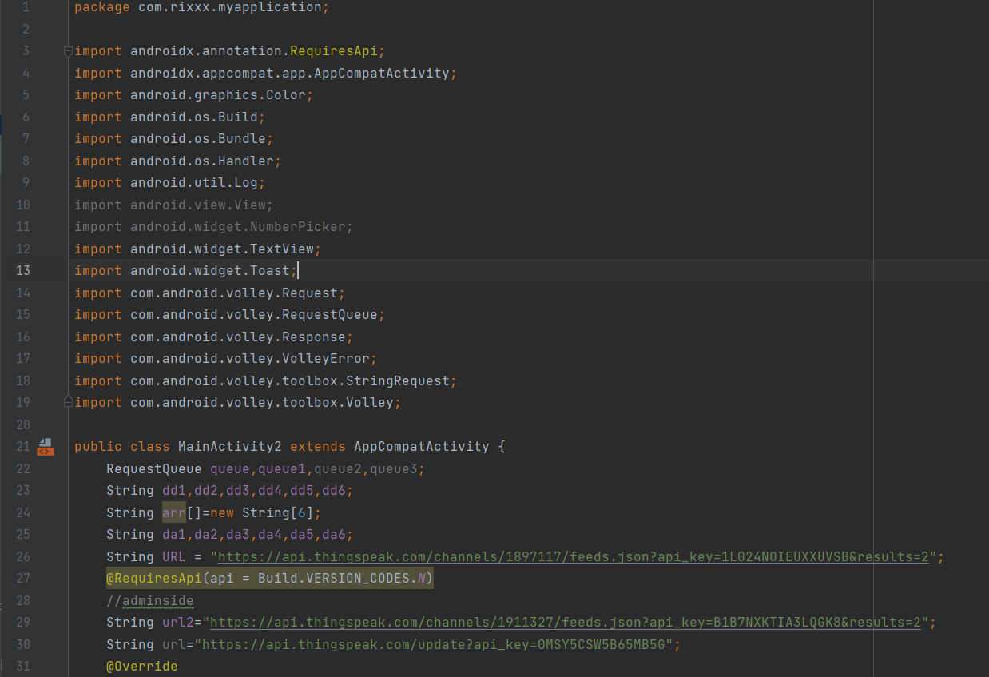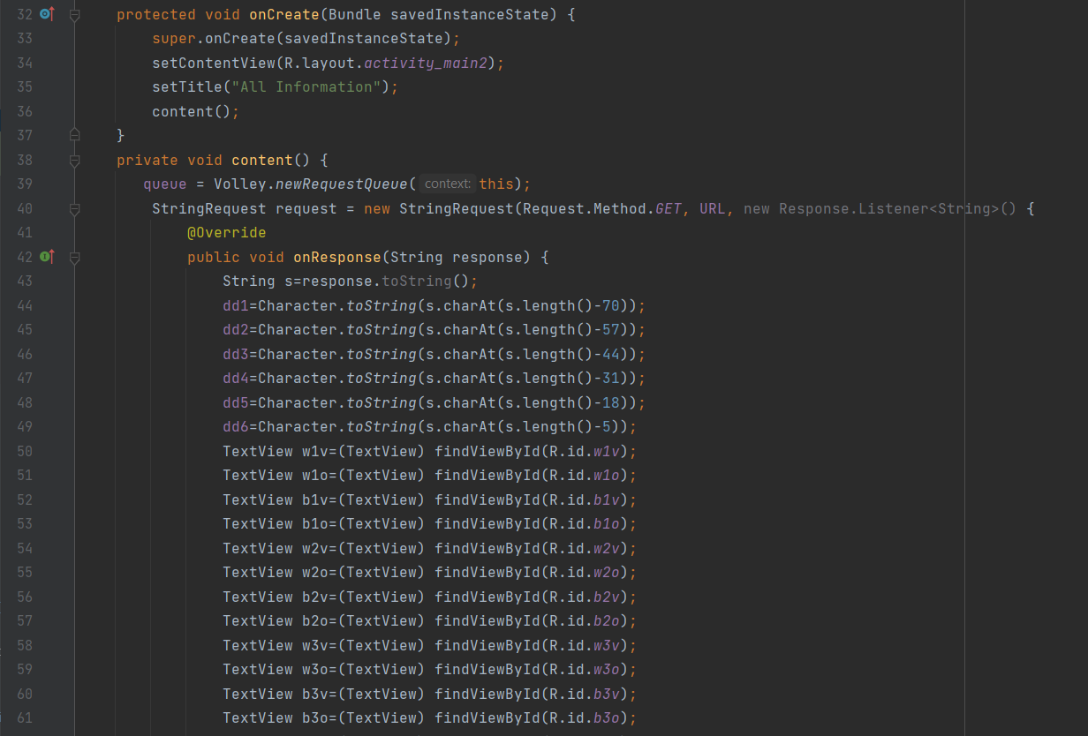

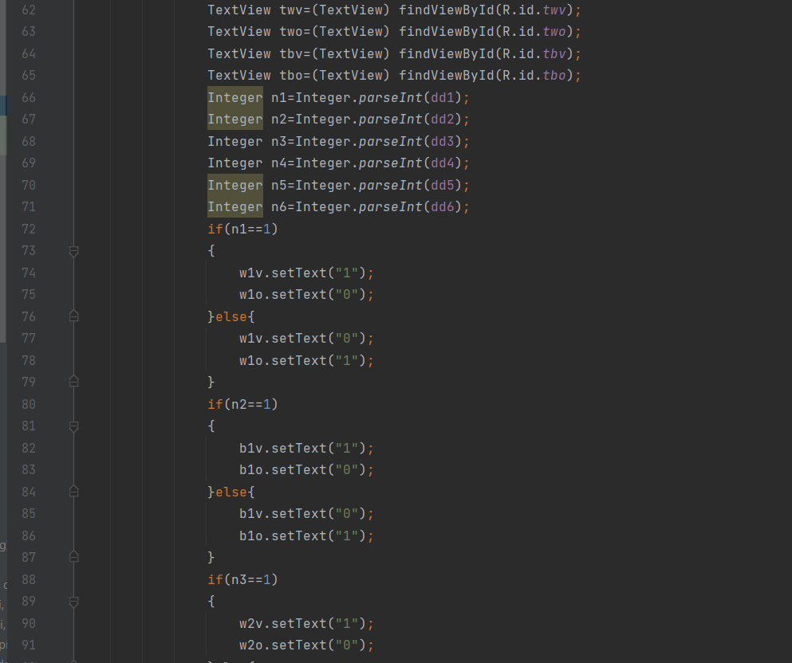

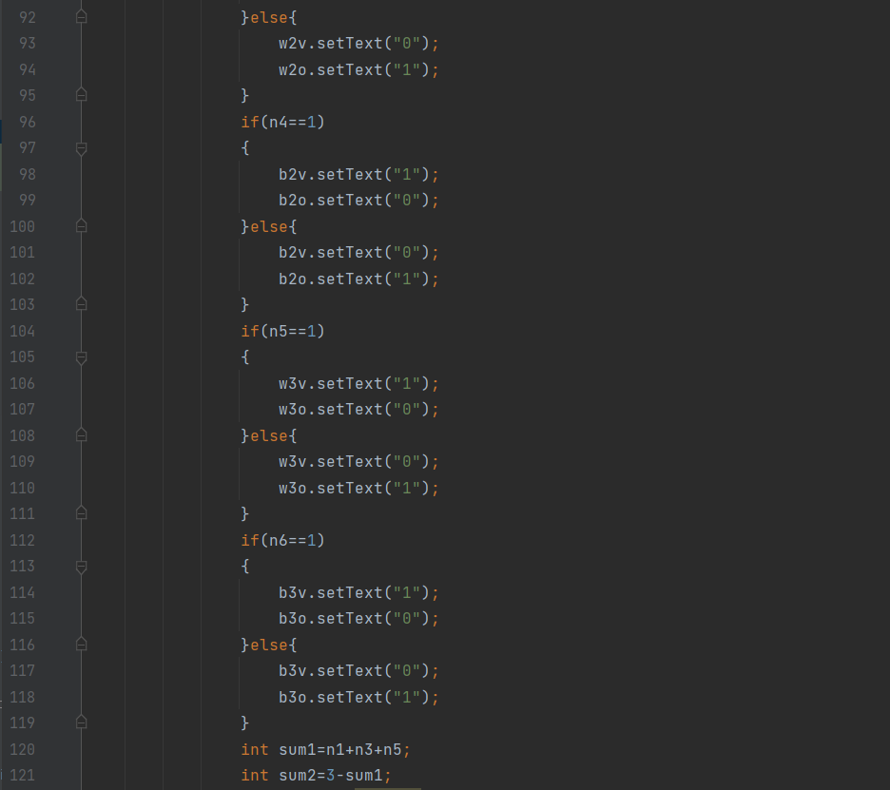

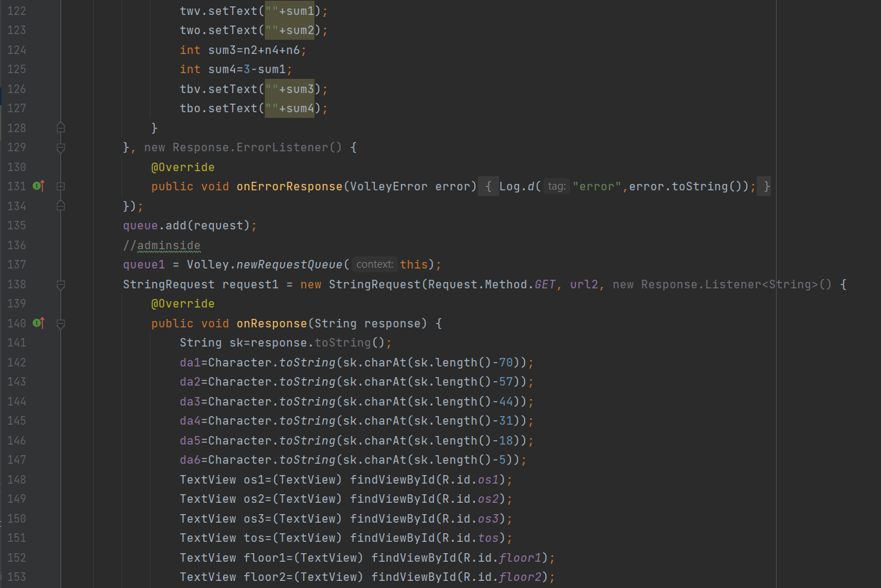

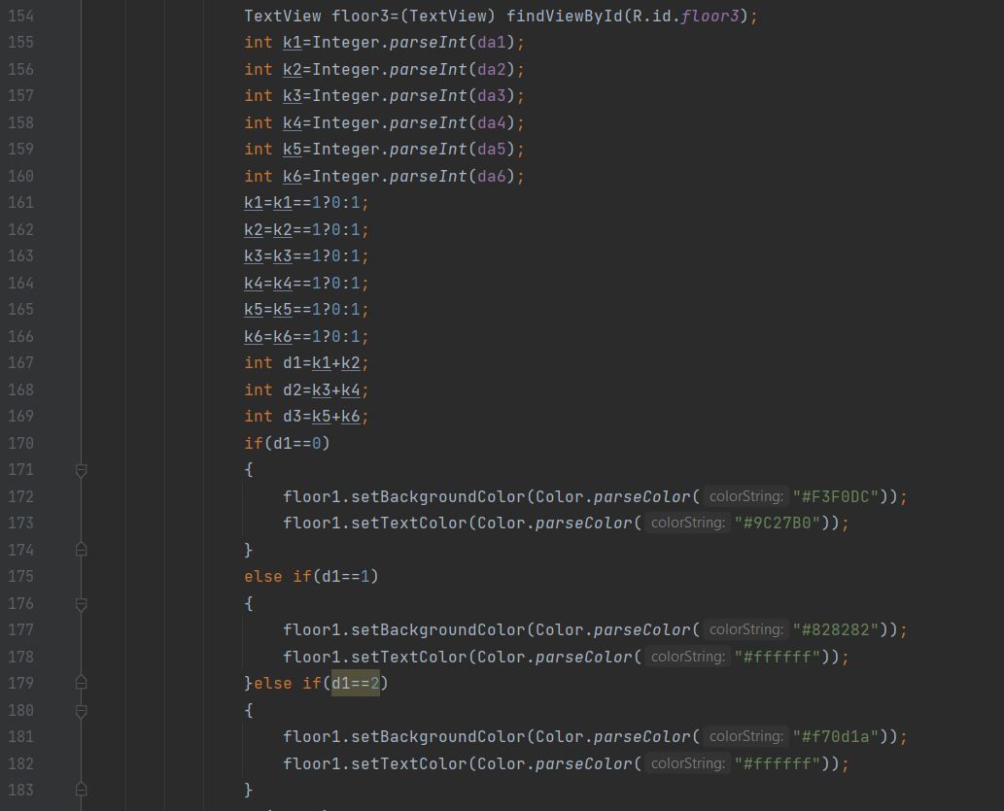

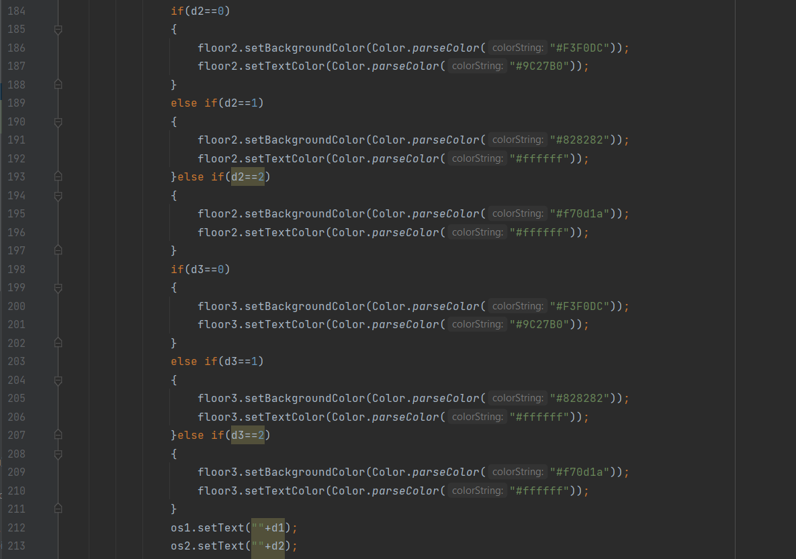

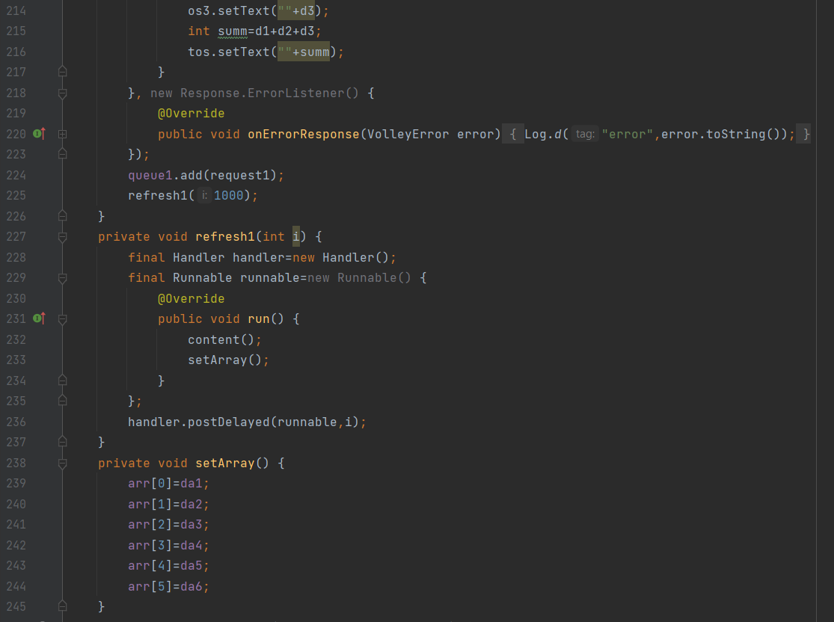

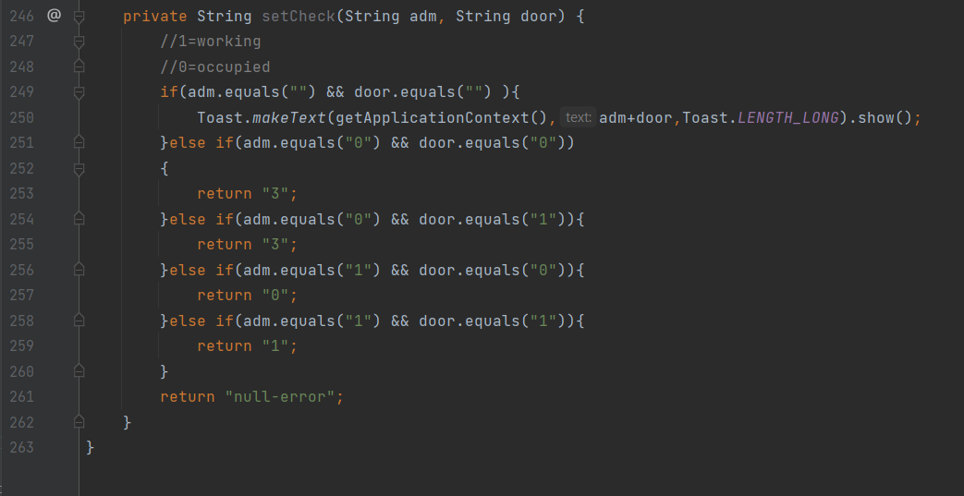

**Components Connections**

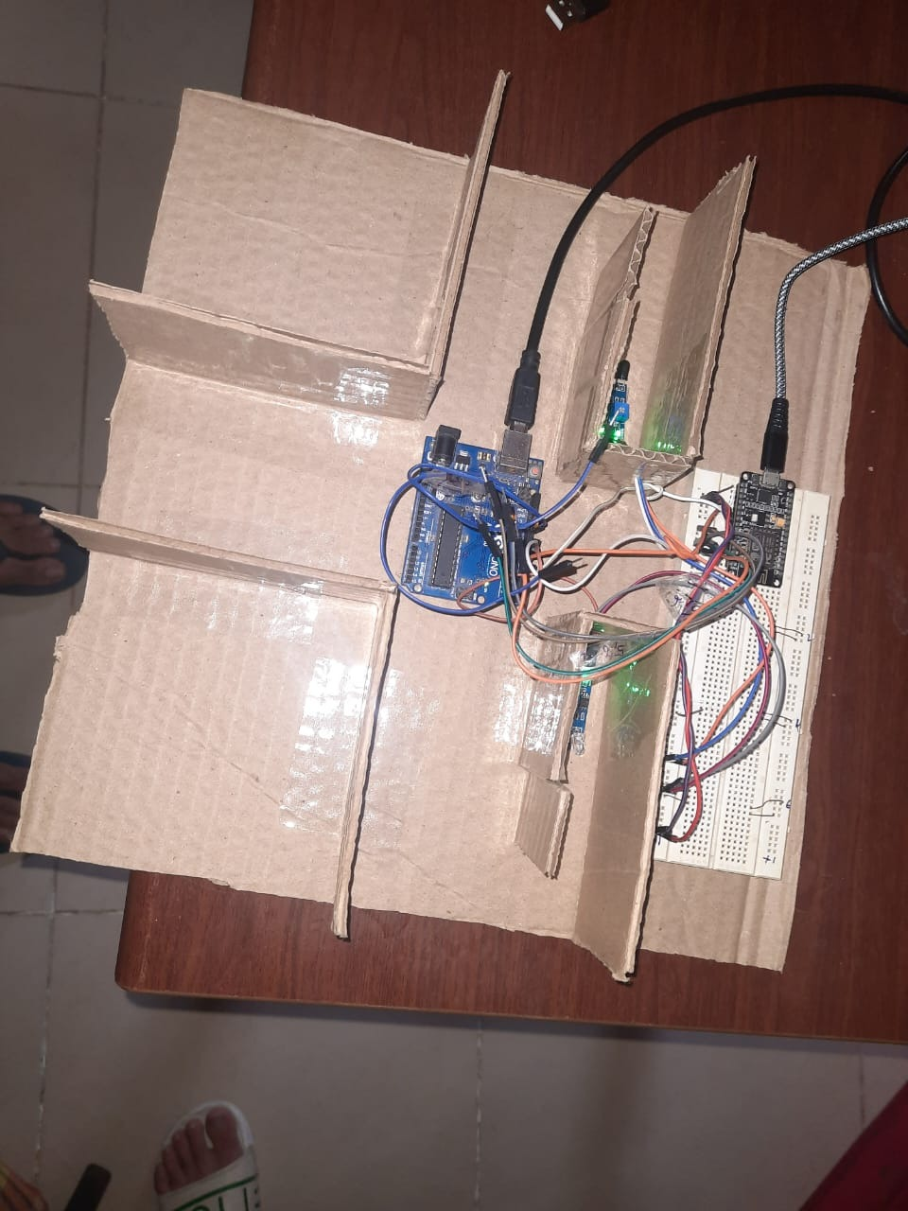

**Results**

In the second image (1) I am working on the connections between the ground floor and the subsequent next floor .

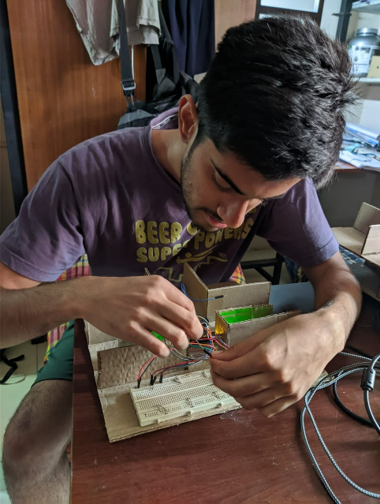         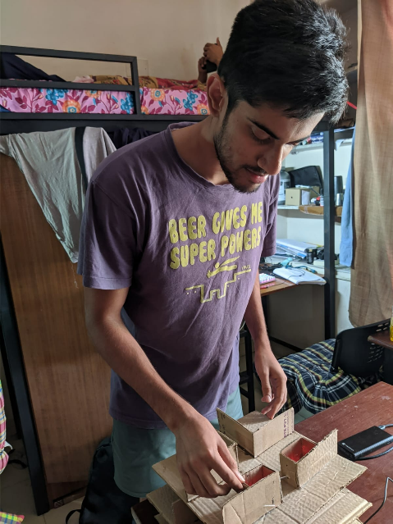

Output Image 1 Output Image 2

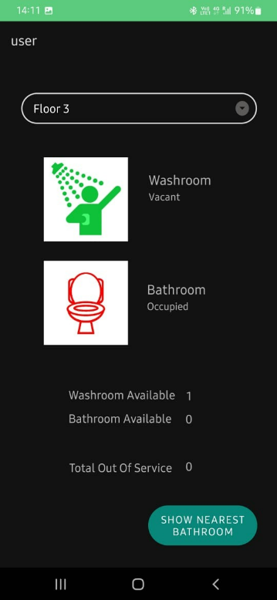                                           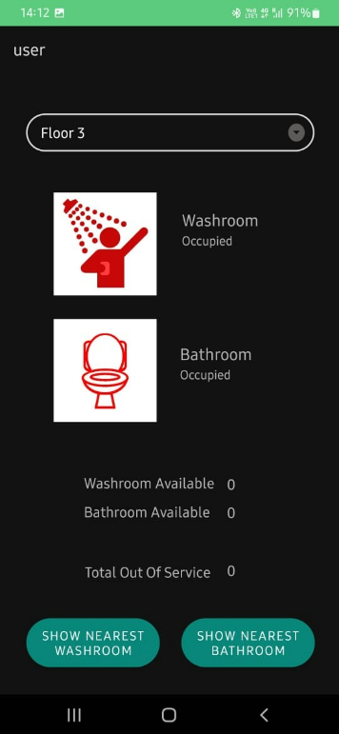

Output Image 3                                                                Output Image 4

Here (2) the washroom door is locked hence the data is updated on server and then the cubicle shows occupied on the app (4).

**Discussion**

**Working Mechanism**

When the hatchbolt of the door closes the IR Sensor will sense it.When it is closed, ‘0’ will be sent to the server.Serial communication takes place between the arduino board and nodeMcu.Then the data is posted to server(channel-washroom) as a JSON object.The data of all the IR sensor are posted at once.

The app will continuously read the data from the server.When the data is ‘1’ the cubicle will be shown vacant.When the data is ‘0’ the cubicle will be shown occupied.

Now if the admin sets the status of a cubicle as out of service.A JSON object will be sent to the server (channel-washroom_admin).If the data is ‘0’ then the washroom will be showed Out of service and if ‘1’ then the washroom will be showed as ‘In service’.

The admin has same functions as user.It also has the option to set the status of washroom.When the All info button is created, the info about each and every washroom will be shown in a tabular form.If one cubicle is out of service,that floor will be highlighted as grey.If both the cubicles are out of service then the floor will be highlighted as red.

The user when opens the app all the data will be read from server.When the user selects the floor the status of each cubicle will be shown.If no washroom on the floor is available then a button will be shown on clicking which the nearest washroom available will be shown and will be redirected to that floor.If no washroom is available then a toast message will be shown saying “No Washroom Available”. Similarly there is a button to show Nearest Bathroom.

**Conclusion**

Since students always need to save their time whenever they can, waiting for washroom cubicles could be a real time killer. Our solution helps the person see the available cubicle in real time so not much time is wasted. This increases their productivity in other tasks.

Our app is easy to use and does not involve any complexities that diminishes the user experience.

This solution also helps solve the user frustration, as they would not have to check every cubicle physically to see if it is available.

Our solution is well optimized for usability and findability.Our app tries to remove ergonomic designs to optimize the user experience.

**References**

1. <https://www.keysolutionsin.com/post/how-to-establish-connection-between-an-arduino-and-an-android-app-using-at-commands>
2. <https://blogs.mathworks.com/iot/2017/12/20/learn-how-to-build-a-custom-android-app-for-a-thingspeak-iot-project/>
3. <https://www.geeksforgeeks.org/volley-library-in-android/>
4. <https://abhiandroid.com/programming/volley>
5. <https://medium.com/vattenfall-tech/android-spinner-customizations-8b4980fb0ee3>
6. <https://abhiandroid.com/ui/custom-spinner-examples.html>
7. <https://www.hackster.io/RoboticaDIY/send-data-from-arduino-to-nodemcu-and-nodemcu-to-arduino-17d47a>
8. <https://create.arduino.cc/projecthub/pawan-kumar3/serial-communication-between-nodemcu-and-arduino-640819>
9. <https://www.google.com/search?q=android+studio+thingspeak&oq=and&aqs=chrome.0.69i59j69i57j69i65j69i60l2j69i65l2j69i60.3043j1j9&sourceid=chrome&ie=UTF-8#fpstate=ive&vld=cid:89a3c5a1,vid:W2HkekSG_Oo>
10. https://iotdesignpro.com/projects/getting-started-with-android-studio-for-internet-of-things